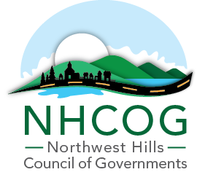
Received 9:55 AM
April 16, 2021
Susan J. Jeanfavre
Assistant Town Clerk

NOTICE OF SPECIAL MEETING BY ZOOM
NHCOG EXECUTIVE COMMITTEE

DATE: Tuesday, April 20, 2021

TIME: 9:00 a.m. – 10:00 a.m.

ZOOM Link:
Meeting ID: 884 6280 5152
Passcode: 941535
Dial by your location:
+1 646 558 8656 US (New York)

AGENDA

1. Call to Order. Don Stein, Chairman.

- Executive Session to Discuss Applications for Executive Director Position.
- Action on Applications for Executive Director Position.
4. Potential Creation of Additional Office Space at the COG.

5. Adjournment.

