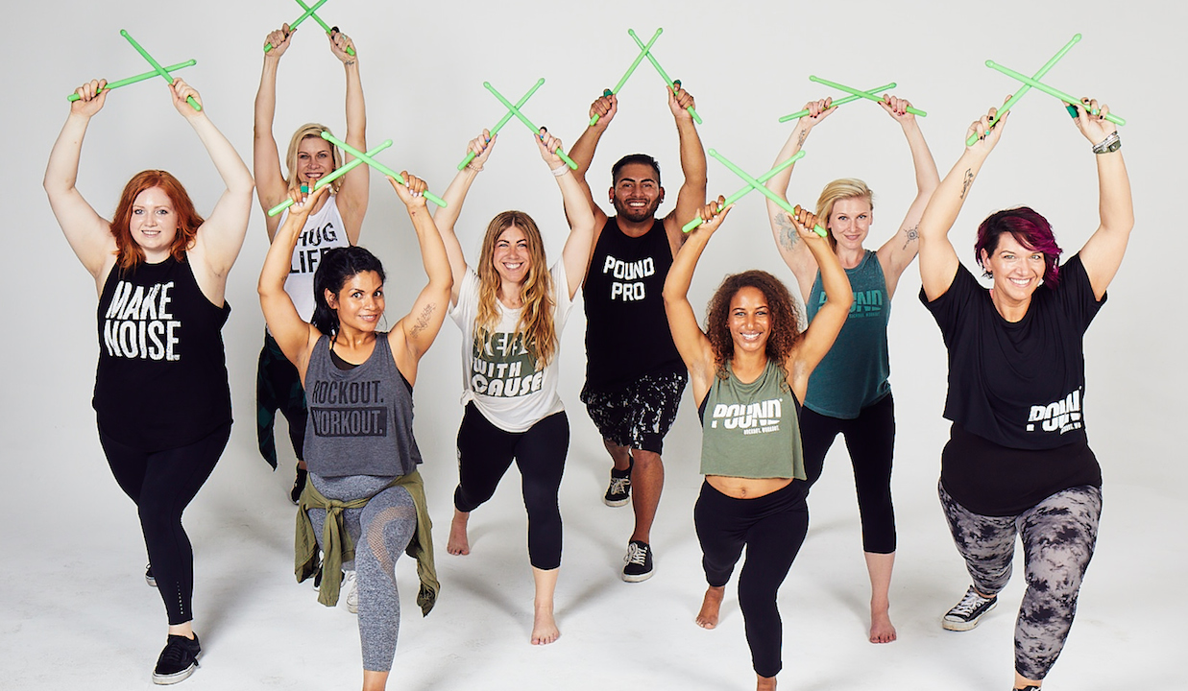
Pound Fitness Blast spring (Two classes a Kids and Teen/Adult program)
Tuesdays- March 18, 25, April 1, 8, 22, 29 and May 6 as a back up day. No program on Tuesday, April 15.
Time: 6:00-6:45 p.m. Kids Class and
7:00-7:45 p.m. Adult Class.
Location: Barkhamsted Elementary School gym
Instructor: Donna Dorbuck (Certified Pound Fitness Instructor)
Registration deadline is Tuesday, March 18, 2025
Register today at; https://forms.gle/WSLSA3dwPYesZE29A

