Register for the Barkhamsted Recreation Department’s
New Summer Programs Today!


Paddle the Farmington River with Barkhamsted Recreation and The FRCC River Stewards (2026 River and Recreation Events) (New) (Two separate events!)
Experience the beautiful vistas of the scenic Farmington River during an evening of fun while paddling with Collinsville Canoe and Kayak, FRCC Summer River Stewards and the Barkhamsted Recreation Department for our River and Recreation Family Event. Spend an enjoyable evening while getting in some great exercise. You can choose whether you would like to kayak or Paddle Board. Whatever your preference, you're sure to have a great time. The cost is $25.00 per person, per event night and the price includes a paddleboard, or kayak, paddle and life vest. The cost is $10 if you have your own supplies. Collinsville Canoe charges $5 for Parking and boat launch and then $5.00 for Barkhamsted Recreation. (Payment must be received one week prior to the program) Lots of smiles and laughs are sure to be had by all. The program is open to adults and families. Children should be ages 6 or over and should be able to swim. Life jackets are required.
Date-Sunday, August 9-Event Night
Time-2:00-4:00 p.m.
Location: Collinsville Canoe and Kayak- 41 Bridge Street, Route 179, Collinsville, CT
Please register at 2026 Paddle Registration link Wed. August 5 for Event 2 so we can have the proper equipment and supervision in place. Mail your check to Barkhamsted Recreation Department, Barkhamsted Town Hall-67 Ripley Hill Road, Barkhamsted, CT 06078 or drop it off in the white mailbox outside town hall in the upper level by the deadline for each event. Once you are registered there are no refunds as we have to give a headcount to Collinsville Canoe and Kayak the head count three days before the event.
You can also bring your payment to the event but Once you are registered there are no refunds as we have to give a headcount to Collinsville Canoe and Kayak the head count before the event.
For any questions, please email- Donna Bastrzycki, Barkhamsted Recreation Director, barkhamstedrec@barkhamsted.us

Looking forward to seeing you there!

Register for Summer Camp with the Barkhamsted Recreation Department

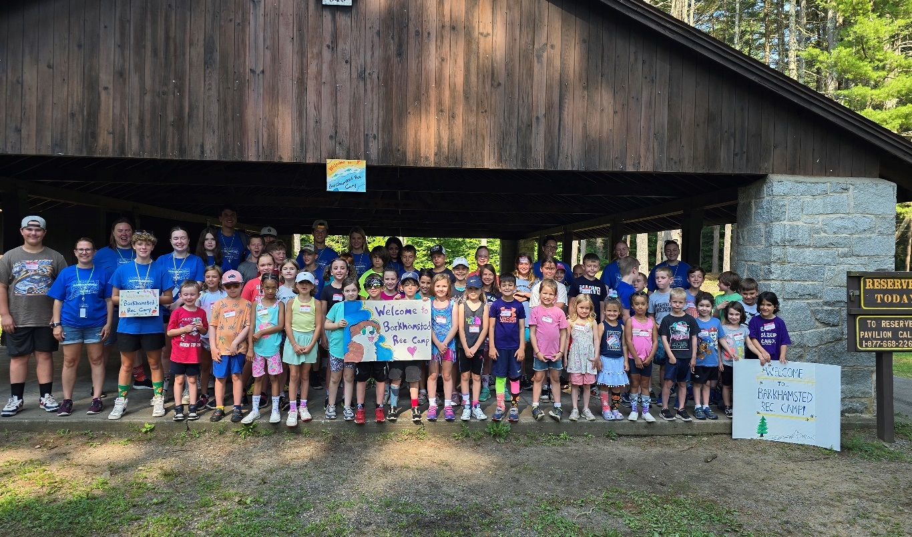
Barkhamsted Recreation Summer Camp
Save the Date!
July 20-24, 2026
Recreation Summer Camp-Save the Date! (July 20-24, 2026)
Get ready for loads of fun at the annual week long Barkhamsted Recreation Camp. There are new special events, crafts and water fun planned for each day. We hope your child will be a part of the 2026 camp! Barkhamsted Recreation Summer camp will be held July 20-24, 2026. The registration for Camp will be held April 3-June 1 or when program is full. Be sure to register early. Spots are limited.
Register at: summer camp 2026 registration link

Summer Help Wanted!
Applications are being accepted for Junior Counselors and volunteers for Summer Camp. Please complete the application from this link-
SummerCampHelpWanted Link
Deadline is-Monday, July 13 or when positions are full (completed applications must be received by this date.)
Please mail or drop off summer payments to Barkhamsted Parks and Recreation Department -67 Ripley Hill Road Pleasant Valley, CT 06063 and also in the white drop box in front of town hall. Karate, Pound and Pickleball payments can be brought on the first night of the program. Please sign up before the deadlines to reserve your spot for programs and ensure your spot and “like” the town of Barkhamsted on Facebook to stay up to date with current events and programs.

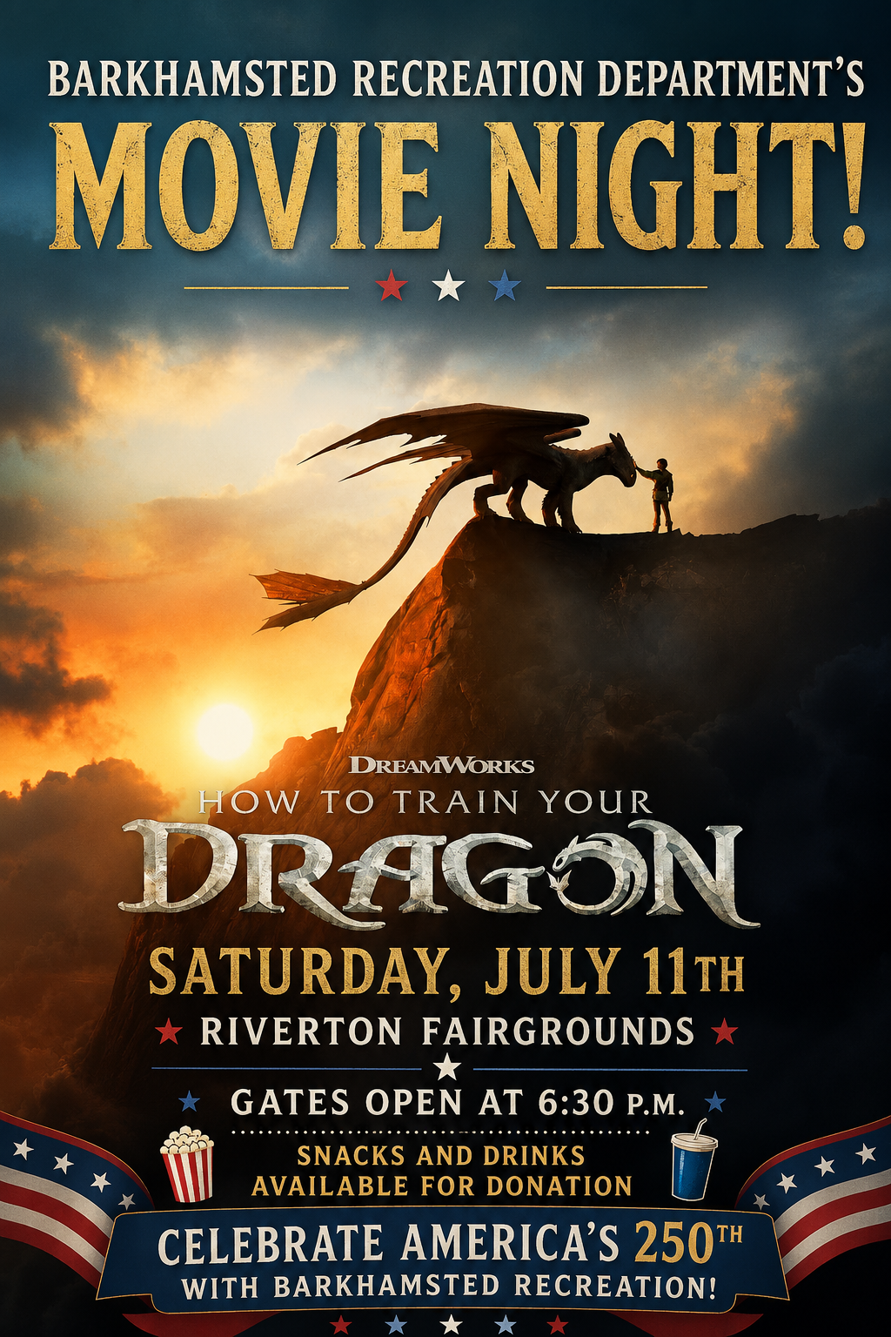
Movie Night at the Riverton Fairgrounds-How To Train Your Dragon
🐉Get Ready for "How To Train Your Dragon" Movie Under the Stars, Celebrating America's 250th!
The Barkhamsted Recreation Department invites you to a magical Movie Night At the Riverton Fairgrounds that you won't want to miss!
This year, as our nation honors 250 Years of Courage, Adventure, and Freedom, we are celebrating that spirit with a story about finding the courage to challenge the impossible, discovering new horizons, and proving that one person can change the world.
Join your community for a special screening of How to Train Your Dragon—a film that perfectly captures the bravery, friendship, and leap of faith that defined our nation's founders 250 years ago! Just like America's journey, Hiccup’s story reminds us that the greatest adventures begin with courage, compassion, and believing in something bigger than yourself.
📅 EVENT DETAILS
- When: Saturday, July 11
- Where: Riverton Fairgrounds, Riverton, CT
- Time: Gates open at 6:30 p.m. | Movie begins at dusk
- Admission: FREE! 🎟️
- Food: Snacks & drinks will be available for a donation.
Bring your lawn chairs, blankets, and your sense of adventure for an unforgettable evening beneath the summer sky! 🍿🌌
🤝 We Need Your Help! (Sponsors & Volunteers)
To make this milestone celebration a massive success, the Barkhamsted Recreation Department is actively looking for event sponsors and volunteers! If you want to support the community and be a part of this historic year's events, please reach out.
📧 Interested? Contact Donna Bastrzycki, Barkhamsted Recreation Director, at barkhamstedrec@barkhamsted.us today!
❤️ Build memories with family. 🤍 Celebrate our community. 💙 Honor America's 250th. 🐉 Experience an unforgettable adventure under the stars.
Tag your movie crew, invite your neighbors, and share this post to help us celebrate Barkhamsted and America's 250th together! 🇺🇸🎉

Please mail or drop off summer payments or required forms to Barkhamsted Parks and Recreation Department -67 Ripley Hill Road Pleasant Valley, CT 06063 and also in the white drop box in front of town hall. Please sign up before the deadlines to reserve your spot for programs and ensure your spot and “like” the town of Barkhamsted on Facebook to stay up to date with current events and programs.

