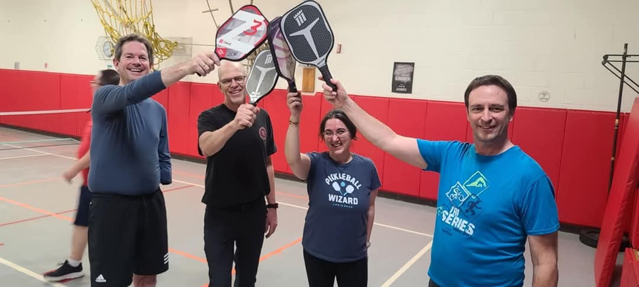

New Pickleball Late Winter and Spring 2025 Session!

Spring PickleBall Program dates-Day-Wednesdays
Location-Barkhamsted Elementary School gym
Time: 6:00-9:00 p..m.
Dates-Demo Night March 12, March 26, April 2, 9, 23, 30, May 7, 14 and then May 21 as a back up bad weather night. These are all Wednesday Nights!
Location-Barkhamsted Elementary School Gym Time-6:00-9:00 p.m. (this program is for adults and high school students are also welcome)
Please register through this link- https://forms.gle/ccvc31ACZ4G9AH3i7
Fee: $20.00 for residents, $25.00 for non-residents (no pro-rations) Pre-registration is required. Please bring your own paddle and wear sneakers. Please mail your registration to The Barkhamsted Recreation Department- Attention Donna Bastrzycki-Recreation Director 67 Ripley Hill Road, Pleasant Valley, CT 06063
To learn more about Pickleball visit-https://www.pickleballcentral.com/Pickleball_Videos_s/204.htm
https://www.youtube.com/watch?v=x3ZLjn88JiY

(If the Barkhamsted Elementary school is cancelled due to snow/bad weather there will be no program) We will try to add on a week if possible at the end of the session.
Payment Registration Deadline-Wednesday, March 12 at the first night of Pickleball

Recreation Summer Camp-Save the Date! (July 13-17, 2025)
Get ready for loads of fun at the annual week long Barkhamsted Recreation Camp. There are new special events, crafts and water fun planned for each day. We hope your child will be a part of the 2025 camp! Barkhamsted Recreation Summer camp will be held July 13-16, 2025. The registration for Camp will be held April 1-June 3 or when program is full. Be sure to register early. Spots are limited.

Please sign up for the Town’s mailing list and like the Town of Barkhamsted on Facebook to stay up to date on programs. www.barkhamsted.us

Summer Help Wanted!
Applications are being accepted for Counselors, Junior Counselors and staff for Summer Camp. Please complete the application from this link-

Deadline is-Monday, April 6 or when positions are full (completed applications must be received by this date.)

Please mail or drop off summer payments or required forms to Barkhamsted Parks and Recreation Department -67 Ripley Hill Road Pleasant Valley, CT 06063 and also in the white drop box in front of town hall. Karate, Pound Fitness and Pickleball payments can be brought on the first night of the program. Please sign up before the deadlines to reserve your spot for programs and ensure your spot and “like” the town of Barkhamsted on Facebook to stay up to date with current events and programs.

