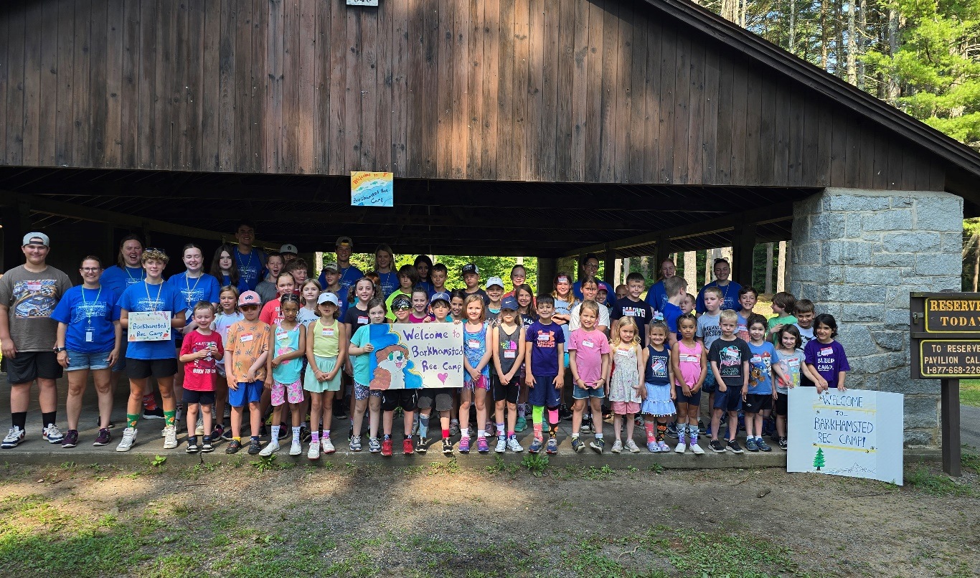
Barkhamsted Recreation Summer Camp
Save the Date!
July 14-18, 2025
Recreation Summer Camp-Save the Date!
(July 14-18, 2025)
Get ready for loads of fun at the annual week long Barkhamsted Recreation Camp. There are new special events, crafts and water fun planned for each day. We hope your child will be a part of the 2025 camp! Barkhamsted Recreation Summer camp will be held July 14-18, 2025. The registration for Camp will be held April 1-June 3 or when program is full. Be sure to register early. Spots are limited.
Register at: https://forms.gle/L2b3sei2DndL8NTx7

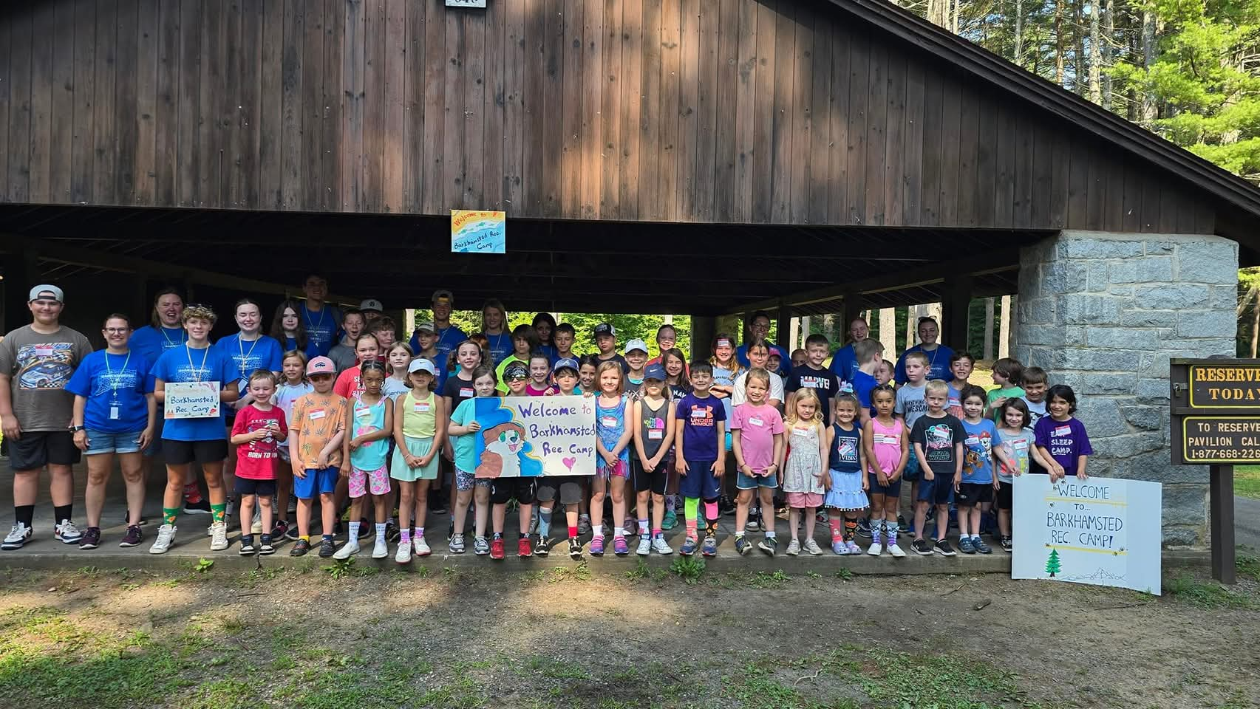

Summer Help Wanted!
Join our fantastic summer camp team!
Applications are being accepted for Counselors, Junior Counselors and staff for Summer Camp and staff for our summer family fun day and events!
Please complete the application from this link- https://forms.gle/EVhCmokxiV88yXRJA
Deadline is Friday, May 23 or when positions are full (completed applications must be received by this date.)

Summer Field Hockey Fun


Come join Granby Memorial High School Coach Kierstan Pestana to learn new skills or improve the ones you already have! Whether you've never held a stick before or have been playing for years, Coach Pestana will develop your skills and play games to improve your understanding and execution of the game.

Practice, play and passion for this sport will all be a part of these sessions.
Participants will need a mouthguard, shin guards, and a stick (a limited amount of sticks will be available to borrow). This program will be tons of fun for those interested in this great sport!! PLEASE bring a water bottle!

Grade levels: Entering 3rd grade through 8th grade

Dates: June 16th-20th

Time: 8:00-10:00 AM

Location: Barkhamsted Elementary School field (In case of inclement weather, we will be inside BES)

Cost: $125.00

Register at https://forms.gle/Uk9et7suSU5W3y2N6 by June 6, 2025

Questions: Email Kierstan Pestana at: kvpestana@yahoo.com

***A minimum of 10 players are needed with a maximum of 25 players.

New players: when going to a sports store to buy equipment, provide two (2) measurements for the correct size stick: 1) from hipbone to floor and 2) height.

