Register for Fun Programs with the Barkhamsted Recreation Department
New Pickleball Late Winter and Spring 2026 Session!
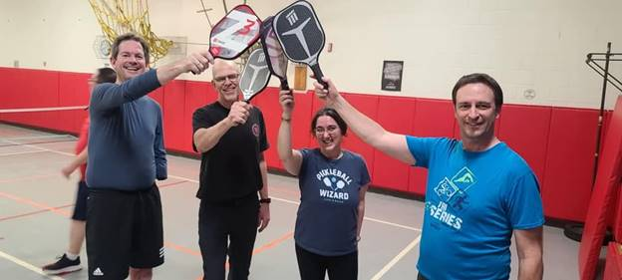 End of Winter/Spring Pickleball

It is time to get off the couch and join us for the very fun and new Pickleball Spring Session. All levels and abilities are welcome. This fun sport combines many elements of tennis, badminton and ping-pong. You will get great exercise and have a blast.
Day-Wednesdays
Location-Barkhamsted Elementary School gym
Time-6:00-9:00 p.m. (this program is for adults (high school students are also welcome)
Dates- March 4, 11, 25, April 1, 8, 22, 29, May 6, May 13 is a backup bad weather day.
Please pre-register through this link- https://forms.gle/J3F9eBLuwnhgWoyP6
Fee: $20.00 for residents, $25.00 for non-residents (no pro-rations) Pre-registration is required. Registration deadline is February 18 at Demo night. Please bring your own paddle and wear sneakers. Please mail your registration to The Barkhamsted Recreation Department- Attention Donna Bastrzycki-Recreation Director 67 Ripley Hill Road, Pleasant Valley, CT 06063 or bring your payment to the program. If there is no school or an early release-there will be no Pickleball that evening.

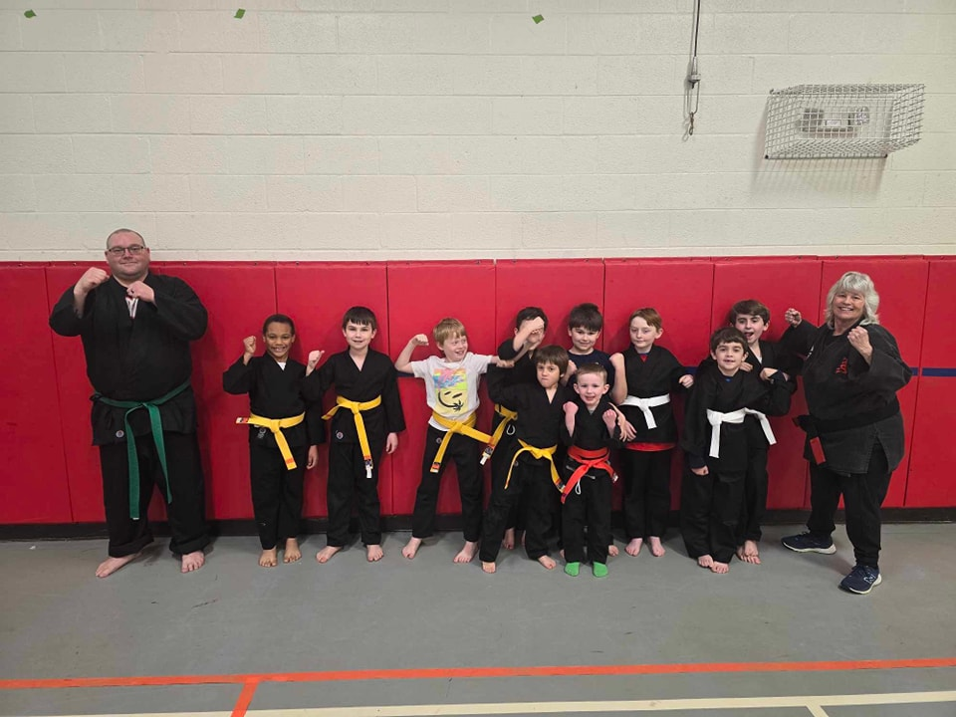
Spring Karate
Spring Karate 2026 (For Children and Adults)
Children’s Program- Class 1
Thursdays, 3/26, 4/2, 4/9, 4/23, 4/30, 5/14, the program will be held in the Barkhamsted Elementary School in the Gym or Library from 6:00-6:45 p.m. (No Class on May7)
White Belts (Beginners ages 5 to 12)
Little Dragons-(ages 5 & 6)-Basic Karate skills, Basic Kata, target drills and exercise, simple self defense
Mighty Tigers (ages 7 & 8)-Stronger Karate basics and Kata, Stretching, exercise, target drills and self defense
Karate Rangers (ages 9-12)-Karate Basics, including kicking, kata, self-defense, exercise to level, target drills
Fee: $60.00 for the eight-week session (New-$5.00 discount for each additional family member that signs up) ***Note***New students are white belts and receive uniform
Fee includes: Belt and/or Stripe, Belt or Stripe Test and Certificate (Note: Promotion to higher belt levels will require multiple sessions)

Family/Teen and Adult Karate – Class 2
Thursdays, 3/26, 4/2, 4/9, 4/23, 4/30, 5/14, program will be held in the Barkhamsted Elementary School in the Gym or Library from 7:00-7:45 p.m. (No Class on May7) in the Gym or Library 7:00-7:45 p.m.
White Belts (Beginners ages 13 and up)-7:00 to 7:45 p.m.
Teen/Adults-(Ages 13 and up)-Kenpo Karate Forms and Self Defense Techniques, Basic kicking drills.
This is a great opportunity to learn karate with family members or solo.
$60.00 per 6 week sessions New-$5.00 discount for each additional family member that signs up for Karate!
***Note***New students are white belts and receive uniform
Please pre-register through this link- spring Karate 2026 link

Egg Hunt and Visit with the Easter Bunny and Photos

When: Saturday, April 4 from 1:00-3:00 p.m.
Where: (The Riverton Fair Grounds) Riverton, CT
The Easter Bunny will be visiting the Shops in Riverton first (2 School Street, Riverton, CT) so be sure to go over and say hi before heading over the Riverton Fair Grounds. The egg hunt will begin at approximately 1:30 p.m. (Please don’t be late!!) We have prize categories for all ages and this year; we will have an egg hunt for adults. (Some eggs will have coupons and prizes from local Riverton and Barkhamsted vendors!!) What to Bring: Please be sure to bring an Easter Basket or bag for you and your child to join in on the Easter Egg Hunt, a smile! The children will be divided into two separate age groups for a toy and candy filled Easter Egg Hunt sponsored by the Recreation Commission. Then parents and caregivers will have their chance to go on their own egg hunt too!! The Event will be held rain, snow or shine!!! (If you are a local vendor/business owner and would like to participate or contribute to the prizes, please contact Donna Bastrzycki, Barkhamsted Recreation Director barkhamstedrec@barkhamsted.us
Register today at: Easter egg hunt 2026
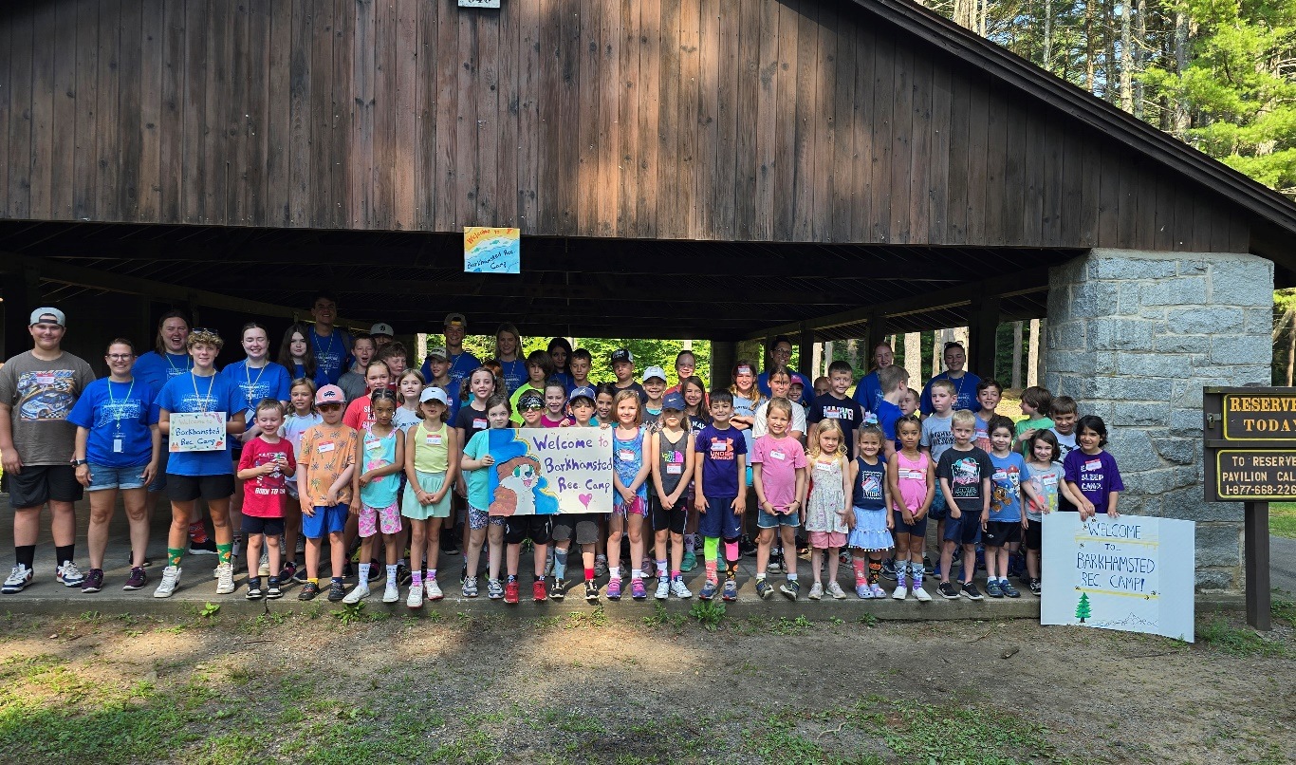
Barkhamsted Recreation Summer Camp
Save the Date!
July 20-24, 2026
Recreation Summer Camp-Save the Date! (July 20-24, 2026)
Get ready for loads of fun at the annual week long Barkhamsted Recreation Camp. There are new special events, crafts and water fun planned for each day. We hope your child will be a part of the 2026 camp! Barkhamsted Recreation Summer camp will be held July 20-24, 2026. The registration for Camp will be held April 3-June 1 or when program is full. Be sure to register early. Spots are limited.
Register at: summer camp 2026 registration link

Summer Help Wanted!
Applications are being accepted for Counselors, Junior Counselors and staff for Summer Camp. Please complete the application from this link-
SummerCampHelpWanted Link
Deadline is-Monday, April 6 or when positions are full (completed applications must be received by this date.)
Please mail or drop off summer payments to Barkhamsted Parks and Recreation Department -67 Ripley Hill Road Pleasant Valley, CT 06063 and also in the white drop box in front of town hall. Karate, Pound and Pickleball payments can be brought on the first night of the program. Please sign up before the deadlines to reserve your spot for programs and ensure your spot and “like” the town of Barkhamsted on Facebook to stay up to date with current events and programs.

Please remember for all Barkhamsted Recreation Programs is there is No School or a early release due to weather for Regional 7 then then programs are also canceled for that evening.

