Register for Summer Camp with the Barkhamsted Recreation Department

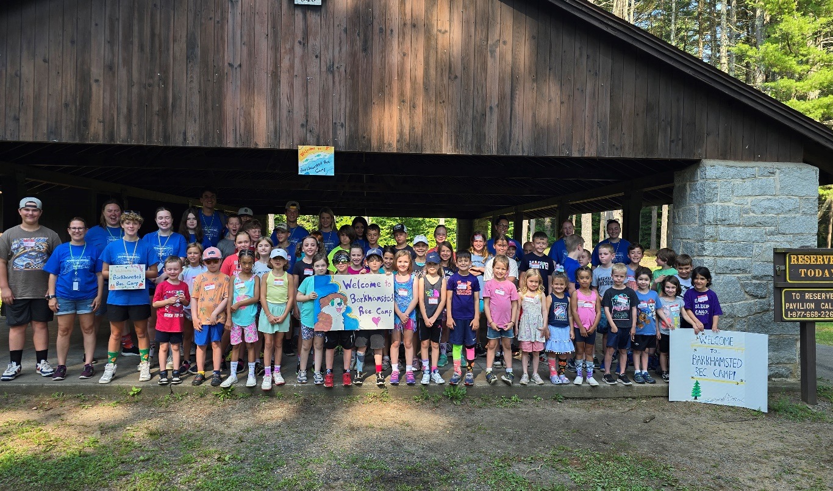
Barkhamsted Recreation Summer Camp
Save the Date!
July 20-24, 2026
Recreation Summer Camp-Save the Date! (July 20-24, 2026)
Get ready for loads of fun at the annual week long Barkhamsted Recreation Camp. There are new special events, crafts and water fun planned for each day. We hope your child will be a part of the 2026 camp! Barkhamsted Recreation Summer camp will be held July 20-24, 2026. The registration for Camp will be held April 3-June 1 or when program is full. Be sure to register early. Spots are limited.
Register at: summer camp 2026 registration link

Summer Help Wanted!
Applications are being accepted for Counselors, Junior Counselors and staff for Summer Camp. Please complete the application from this link-
SummerCampHelpWanted Link
Deadline is-Monday, April 6 or when positions are full (completed applications must be received by this date.)
Please mail or drop off summer payments to Barkhamsted Parks and Recreation Department -67 Ripley Hill Road Pleasant Valley, CT 06063 and also in the white drop box in front of town hall. Karate, Pound and Pickleball payments can be brought on the first night of the program. Please sign up before the deadlines to reserve your spot for programs and ensure your spot and “like” the town of Barkhamsted on Facebook to stay up to date with current events and programs.

Please remember for all Barkhamsted Recreation Programs is there is No School or a early release due to weather for Regional 7 then then programs are also canceled for that evening.

