Register for the Barkhamsted Recreation Department’s
New Summer Programs Today!


Paddle the Farmington River with Barkhamsted Recreation and The FRCC River Stewards (2026 River and Recreation Events) (New) (Two separate events!)
Experience the beautiful vistas of the scenic Farmington River during an evening of fun while paddling with Collinsville Canoe and Kayak, FRCC Summer River Stewards and the Barkhamsted Recreation Department for our River and Recreation Family Event. Spend an enjoyable evening while getting in some great exercise. You can choose whether you would like to kayak or Paddle Board. Whatever your preference, you're sure to have a great time. The cost is $25.00 per person, per event night and the price includes a paddleboard, or kayak, paddle and life vest. The cost is $10 if you have your own supplies. Collinsville Canoe charges $5 for Parking and boat launch and then $5.00 for Barkhamsted Recreation. (Payment must be received one week prior to the program) Lots of smiles and laughs are sure to be had by all. The program is open to adults and families. Children should be ages 6 or over and should be able to swim. Life jackets are required.
Date-Friday, June 5 from 6:00-8:00 p.m.
and Sunday, August 9-Event Night
Time-2:00-4:00 p.m.
Location: Collinsville Canoe and Kayak- 41 Bridge Street, Route 179, Collinsville, CT
Please register at 2026 Paddle Registration link by Wed. June 3 for Event 1 and Wed. August 5 for Event 2 so we can have the proper equipment and supervision in place. Mail your check to Barkhamsted Recreation Department, Barkhamsted Town Hall-67 Ripley Hill Road, Barkhamsted, CT 06078 or drop it off in the white mailbox outside town hall in the upper level by the deadline for each event. Once you are registered there are no refunds as we have to give a headcount to Collinsville Canoe and Kayak the head count three days before the event.
You can also bring your payment to the event but Once you are registered there are no refunds as we have to give a headcount to Collinsville Canoe and Kayak the head count before the event.
For any questions, please email- Donna Bastrzycki, Barkhamsted Recreation Director, barkhamstedrec@barkhamsted.us

Looking forward to seeing you there!

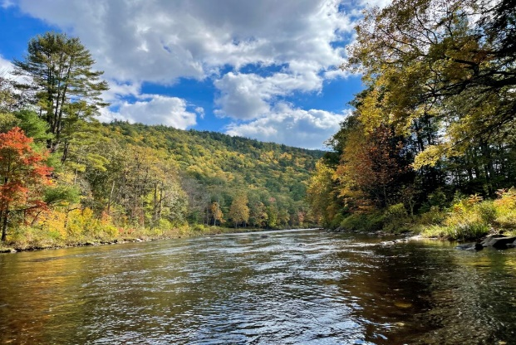
Summer Fun Day by the River at Peoples State Forest 2026-River and Recreation Series Summer Event
Summer Fun Day by the River at Peoples State Forest will be held on Sunday, June 28 from 1:00-3:00 p.m. Join us for the new River and Recreation Series Summer Event at Peoples State Forest- (in front of Squires Tavern-The Barkhamsted Historical Society.) Crafts, games, corn hole competitions and activities are for adults, families and children from 1:00-3:00 p.m. and the event will be led by the Barkhamsted Recreation Camp staff and the 2026 FRCC Assistant River Steward Team. You will have a blast while making new friends and learning more about the Wild and Scenic Farmington River, area hiking and recreational programs, meet the 2026 FRCC River Steward Team and members of the Barkhamsted Recreation staff and play a variety of games, make crafts and even have the opportunity to go on a Nature Scavenger hunt! Meet at the picnic tables at Squires Tavern/Bakrhamsted Historical Society. Please register by Wed, June 25 so that we can plan for the necessary supplies and craft items. Small snacks will also be served. This event is free!
When-Sunday June 28 Time-1:00-3:00 p.m.
Location-Squires Tavern/Barkhamsted Historical Society Red Barn-100 East River Road, Barkhamsted, CT
Fee-FREE (This is a FREE community event for all ages)
Register at- Summer Fun Day By the River Registration link
For any questions, please email- Donna Bastrzycki, Barkhamsted Recreation Director, barkhamstedrec@barkhamsted.us

Register for Summer Camp with the Barkhamsted Recreation Department

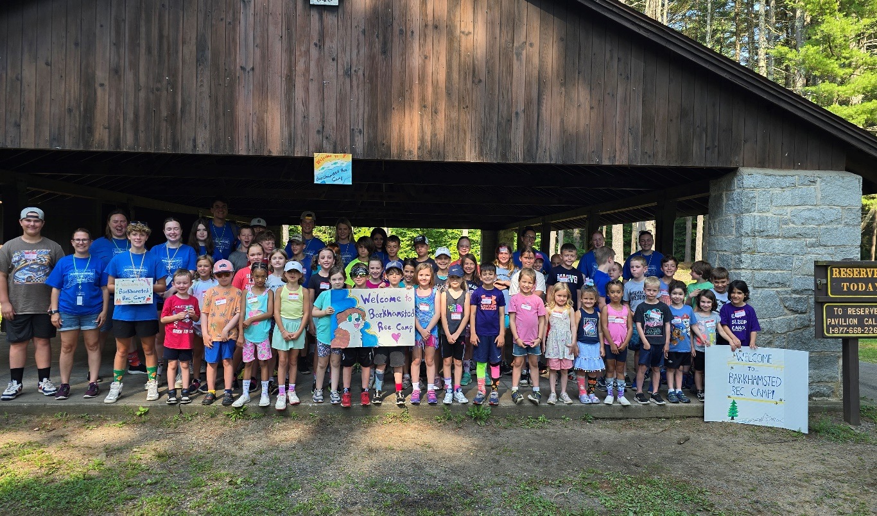
Barkhamsted Recreation Summer Camp
Save the Date!
July 20-24, 2026
Recreation Summer Camp-Save the Date! (July 20-24, 2026)
Get ready for loads of fun at the annual week long Barkhamsted Recreation Camp. There are new special events, crafts and water fun planned for each day. We hope your child will be a part of the 2026 camp! Barkhamsted Recreation Summer camp will be held July 20-24, 2026. The registration for Camp will be held April 3-June 1 or when program is full. Be sure to register early. Spots are limited.
Register at: summer camp 2026 registration link

Summer Help Wanted!
Applications are being accepted for Counselors, Junior Counselors and staff for Summer Camp. Please complete the application from this link-
SummerCampHelpWanted Link
Deadline is-Monday, May 21 or when positions are full (completed applications must be received by this date.)
Please mail or drop off summer payments to Barkhamsted Parks and Recreation Department -67 Ripley Hill Road Pleasant Valley, CT 06063 and also in the white drop box in front of town hall. Karate, Pound and Pickleball payments can be brought on the first night of the program. Please sign up before the deadlines to reserve your spot for programs and ensure your spot and “like” the town of Barkhamsted on Facebook to stay up to date with current events and programs.

Please mail or drop off summer payments or required forms to Barkhamsted Parks and Recreation Department -67 Ripley Hill Road Pleasant Valley, CT 06063 and also in the white drop box in front of town hall. Please sign up before the deadlines to reserve your spot for programs and ensure your spot and “like” the town of Barkhamsted on Facebook to stay up to date with current events and programs.

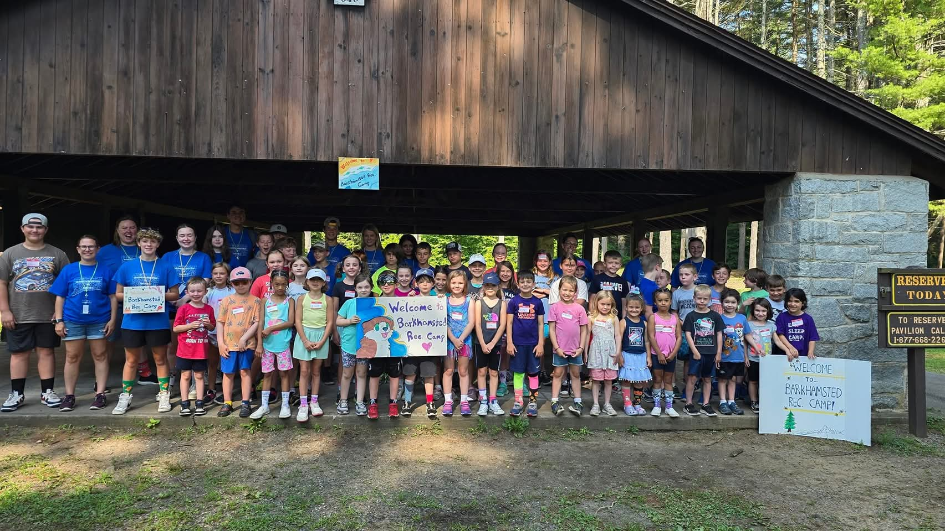Recreation Summer Camp-Save the Date! (July 20-24, 2026)
Get ready for loads of fun at the annual week long Barkhamsted Recreation Camp. There are new special events, crafts and water fun planned for each day. We hope your child will be a part of the 2026 camp! Barkhamsted Recreation Summer camp will be held July 20-24, 2026. The registration for Camp will be held April 3-June 1 or when program is full. Be sure to register early. Spots are limited.
Register at: summer camp 2026 registration link
Summer Help Wanted!
Join our fantastic summer camp team! Applications are being accepted for Counselors, Junior Counselors and staff for Summer Camp and staff for our summer family fun day and events! Please complete the application from this link- https://forms.gle/EVhCmokxiV88yXRJA
Deadline is-Wednesday, May 7 or when positions are full (completed applications must be received by this date.)

