TOWN OF CANAAN
HISTORIC DISTRICT STUDY COMMITTEE

June 23, 2025, 3:30 PM
Falls Village-Canaan Historical Society
44 Railroad St., Falls Village, CT 06031

IN PERSON

MEETING MINUTES

Meeting was called to order at 3:30 PM by co chairman Judy Jacobs. Present: Member Richard Berzine & co chairman Caitlin Jenkins. Because of a lack of a quorum, the consensus was to cancel the meeting at 3:35 PM.

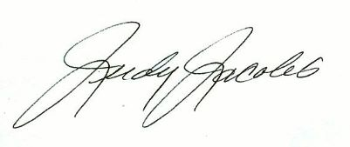
Respectfully submitted,

Judy Jacobs

