FALLS VILLAGE RECREATION COMMISSION
Special Meeting Agenda
Wednesday, August 26th, 2026 – 7pm

In Person: Falls village Town Hall, 108 Main Street, Falls Village, CT 06031

Present members: Catherine Wales, Chris Wadsworth, Matt Gallagher, Dan Carr & Elizabeth Rhoades.

- Call to Order
Chair Catherine Wales called the Meeting to order at 7:08 p.m.

- Approval of minutes from
Dan Carr made a motion to approve the minutes of the August 12th 2026 meeting. Matt Gallagher seconded the motion. Unanimous.

- Town Farm
Events: October Town Farm event timing will be moved later in the day to be 1-4pm in response to the communication received from D. M. Hunt Library.

- Adjournment
There being no further business, the meeting adjourned by unanimous consent at 8:40pm

Next meeting as a Special Meeting:
Thursday, September 10th, 2026 - 6:30pm

Respectfully submitted

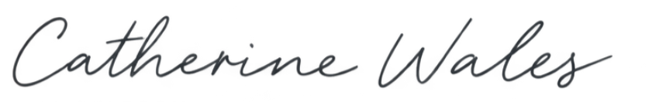

Catherine Wales
Falls Village Recreation Commission

