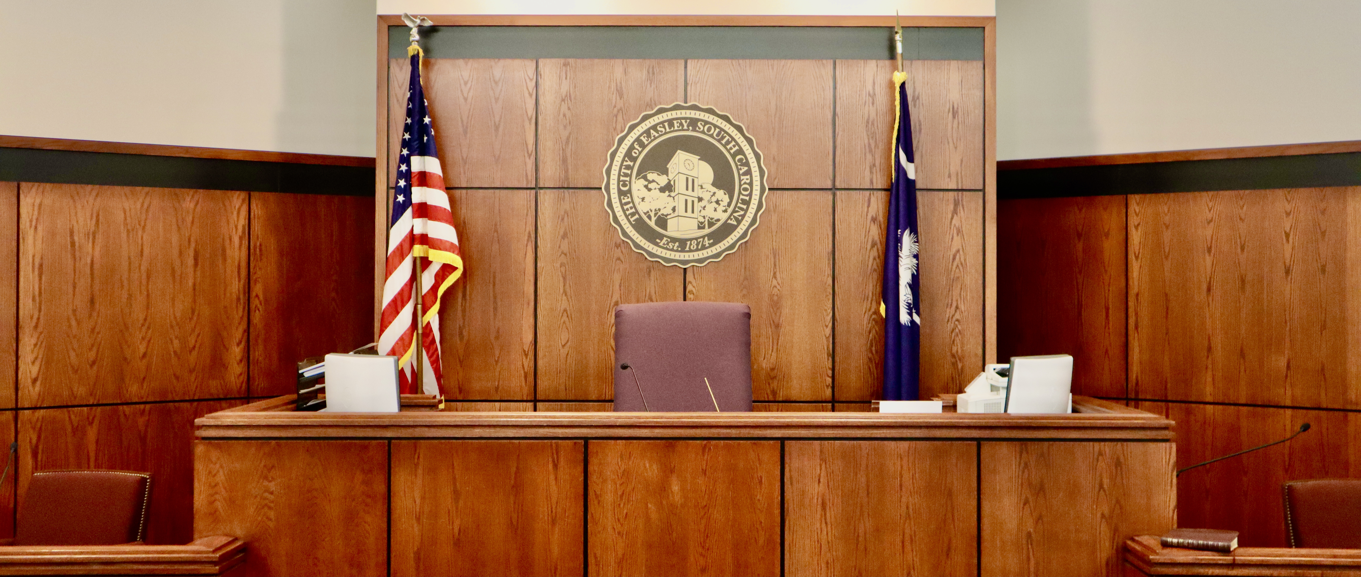

Weekly Schedule for all Court
2026
Easley
Municipal
Court

SUN | MON | TUE | WED | THU | FRI | SAT
Week One | Criminal/Traffic  Court  1.30 PM | Criminal/Traffic  Court  10:00 AM  Code Enforcement  Court  1:30 PM | Criminal/Traffic  Court  9:00 AM  1:30 PM | Criminal/Traffic  Court  9:00 AM  1:30 PM | Preliminary Hearings  9:00 AM
Week Two | Criminal/Traffic  Court  1:30 PM |  | Criminal/Traffic  Court  9:00 AM  1:30 PM | Criminal/Traffic  Court  9:00 AM  1:30 PM
Week Three | Criminal/Traffic  Court  1:30 PM |  | Criminal/Traffic  Court  9:00 AM  1:30 PM | Criminal/Traffic  Court  9:00 AM  1:30 PM
Week Four | Criminal/Traffic  Court 1:30 PM |  | Criminal/Traffic  Court  9:00 AM  1:30 PM | Criminal/Traffic  Court  9:00 AM  1:30 PM
 | This is primarily traffic enforcement court, each Monday at 1:30 PM | This Court is always held on the 1st Tuesday of each month | These are Criminal/Traffic Court Sessions, each Wednesday of each month | These are Criminal/Traffic Court Sessions, each Thursday of each month | Preliminary Hearings are always scheduled for Fridays at 9:00 AM; may not always be on the 1st Friday of each month

