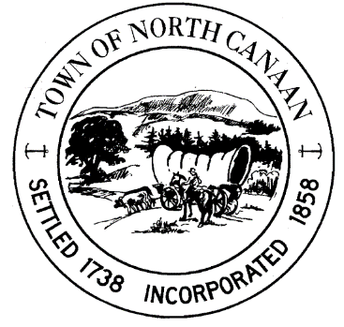 

**North Canaan Events Committee**

**Purpose:** Monthly Meeting – North Canaan Events Committee

**Date:** Monday, July 28, 2025

**Time:**7 PM

**Location:** Town Hall, 100 Pease Street, North Canaan, Connecticut 06018

**Join via Zoom: https://us06web.zoom.us/j/84723361675?pwd=X2b4qeda7ab69amomx6s8WXb3EtjZR.1**

**Meeting ID: 847 2336 1675**  **Passcode: x35ZCH**

**AGENDA**

1. **Call to order**
2. **Approve/Amend Agenda**
3. **Approve/Amend Minutes of the Prior Meetings:**

April 28, 2025

**4) Old Business**

1. Community Tag Sale
2. Summer Nights of Canaan

**5) Treasurer’s report**

**6) New Business**

a) Upcoming community events

b) set date for next roundtable

c) Old Railroad Days

d) Night Markets

e) Conquer the Valley

f) Pumpkin Fest

g) Winter Fest

**7) Next Monthly Meeting:** Mon, Oct 27th, @ 5:30pm

**8) Closing Public Comment Session**

**9) Adjournment**

Respectfully submitted for the North Canaan Events Committee,

Jenn Crane

Chair

* Roberts Rules of Order will be applied. Proper meeting decorum will be adhered to by all hosts and attendees.