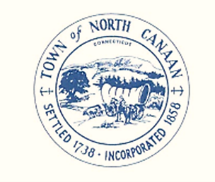
TOWN OF NORTH CANAAN
PLANNING AND ZONING COMMISSION
TOWN HALL 100 PEASE STREET
NORTH CANAAN, CONNECTICUT 06018
(860) 824-7313

Agenda October 11, 2022 7PM
Continuation of public hearing from 9/12/2022

1. Call to order

2. Attendance and Seating of Alternates as necessary

3. Opening remarks

4. Approval of Minutes

5. Presentation for 96 Main Street Project

6. Public Comment

7. Written public Comment

8. Close public hearing.

Regular meeting October 11, 2022

Agenda for regular meeting following public hearing

1. Call to order

2. Attendance and Seating of alternates as necessary

3. Opening Remarks

4. Approval of August minutes as there was no September meeting.

5. ZEO Reports for September and October

Page 2

6. Old business
Community Health and Wellness 6-8 East Main St
96 Main Street Application
Regulation Workshop held on September 26, 2022
Cannabis workshop for regulations

7. Other Business as appropriate to come before the commission

8. Public Comments

9. Adjournment

Respectfully Submitted

George Martin
Zoning Enforcement Officer

