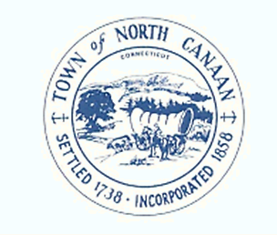
TOWN OF NORTH CANAAN
PLANNING AND ZONING COMMISSION
TOWN HALL 100 PEASE STREET
NORTH CANAAN, CONNECTICUT 06018
(860) 824-7313

Regular Meeting Agenda
April 10, 2023 7pm

1. Call to order

2. Attendance and Seating of Alternates as necessary

3. Opening remarks

4. Approval of Minutes

5. ZEO Report

6. Old business
Old Castle File of complaint

7. New Business

8. Other Business as appropriate to come before the commission

9. Public Comments

10. Adjournment to Next Regular Meeting

Respectfully Submitted

George Martin
Zoning Enforcement Officer

