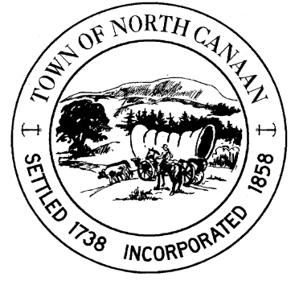
North Canaan Recreation Commission
Purpose: Monthly Meeting – North Canaan Recreation Commission
Date: Monday, November 17, 2025
Time: 7:00 PM
Location: Town Hall, 100 Pease Street, North Canaan, Connecticut 06018
Join via Zoom: https://us06web.zoom.us/j/81997572094?pwd=KrxYLYr0D8FyCsBuwuo3CaL8lLwr4a.1
Meeting ID: 819 9757 2094 Passcode: P9yys6

AGENDA
- Call to Order
- Approve/Amend Meeting Agenda
- Approve/Amend Minutes of the Prior Monthly NCRC Meeting: October 21, 2025
- Public Comment Session
- Director Report
  - Soccer
  - Basketball
  - New storage shed needed for Segalla Field
  - Ski Club – scholarships / sponsorships

- Treasurer Report

- Old Business
  - N.C. Recreation Sponsored Group/Family Events
  - UConn/Future Events
- Canaan Foundation Gathering – Oct 26th @ Colonial Theatre
- Town Monthly Newsletter

- New Business
  - 2026 Meeting dates approval
  - Election of officer positions

- Any other business to come before Commission

- Adjournment – Next NCRC December 16, 2025

Respectfully submitted for the North Canaan Recreation Commission,
Lindsey Crane
North Canaan Recreation Commission Chair

