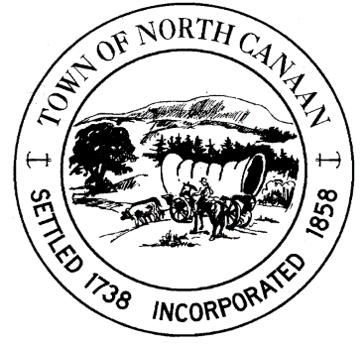
North Canaan Recreation Commission
Purpose: Monthly Meeting – North Canaan Recreation Commission
Date: Tuesday, April 21, 2026
Time: 7:00 PM
Location: Town Hall, 100 Pease Street, North Canaan, Connecticut 06018

AGENDA
- Call to Order
- Approve/Amend Meeting Agenda
- Approve/Amend Minutes of the Prior Monthly NCRC Meeting: March 17, 2026
- Public Comment Session
- Director Report
  - Softball
  - Baseball
  - Tennis Court
  - Pool

- Treasurer Report

- Old Business
  - N.C. Recreation Sponsored Group/Family Events
  - Porto-Potty Deliveries
  - Annual Egg Hunt
- Town Monthly Newsletter

- New Business

- Any other business to come before Commission

- Adjournment – Next NCRC May 19, 2026

Respectfully submitted for the North Canaan Recreation Commission,
Lindsey Crane
North Canaan Recreation Commission Chair

