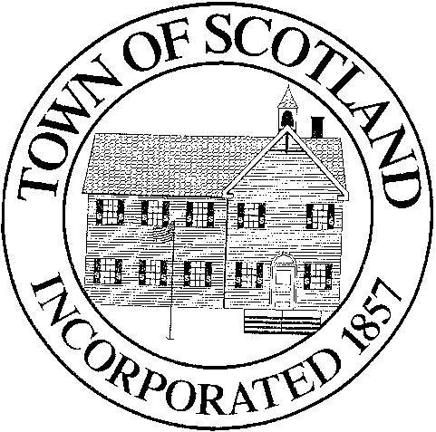TOWN OF SCOTLAND
BOARD OF SELECTMEN

Scotland Town Hall 9 Devotion Road, P.O. Box 288 Scotland, CT 06264
(860) 456-7797 x 101

BOARD OF SELECTMEN
March 10th, 2021

Please join the meeting from your computer, tablet or smartphone.
https://zoom.us/j/91868369799
Meeting ID: 918 6836 9799

Dial by your location
+1 301 715 8592 US (Washington DC)
+1 646 876 9923 US (New York)
Meeting ID: 918 6836 9799
Find your local number:
https://zoom.us/u/ab5gJoc56B

AGENDA
- Call to Order
- Additions to Agenda
- Approval of February 24th, 2021 Meeting Minutes
- Tax Refund – Hillyland Farm Inc. - $18.00
- Appointment of 2 Culture and Recreation Committee Members
- Approval of Suspense List of Taxes
- Approval of schedule for Budget Hearing and Town Meeting
- Report of Selectmen
- Audience for Citizens
- Adjournment

Action Anticipated On Agenda Items

