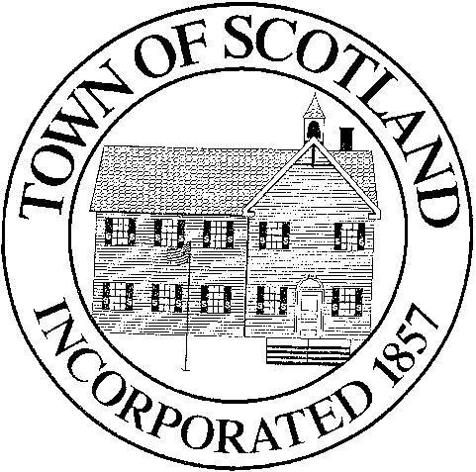
TOWN OF SCOTLAND
BOARD OF SELECTMEN

Scotland Town Hall 9 Devotion Road, P.O. Box 288 Scotland, CT 06264
(860) 456-7797 x 101

BOARD OF SELECTMEN MEETING
December 14th, 2022
Location: Scotland Volunteer Community Hall
47 Brook Road

Meeting is in-person, with online access

Please join my meeting from your computer, tablet or smartphone.
https://meet.goto.com/571365213

You can also dial in using your phone.
Access Code: 571-365-213
United States: +1 (872) 240-3412
Get the app now and be ready when your first meeting starts: https://meet.goto.com/install

AGENDA
- Call to Order
- Audience for Citizens
- Additions to Agenda
- Approval of minutes of the October 26th, 2022 Meeting
- Treasurer’s Report
- Procurement Agreement
- Scotland Elementary School Board of Education CNR Fund Resolution
- Approval of Tax Warrant
- Tax Refund – Justin F. Jalbert for $220.60
- Appointment of Sharon George as Town Clerk & Barbara McKinney as Assistant Town Clerk
- Appointment of Linda Segar to Library Board
- Approval of 2023 Meeting Dates and Holiday Schedule
- Report of Selectmen
- Audience for Citizens
- Adjournment
Action Anticipated on Agenda Items

