COMMUNITY MEETING
6:00 p.m., Wednesday, July 29
Lena Morton Gallery, Town Hall
158 Main Street, Thomaston, CT
Downtown Thomaston
Proposed National Register Historic District
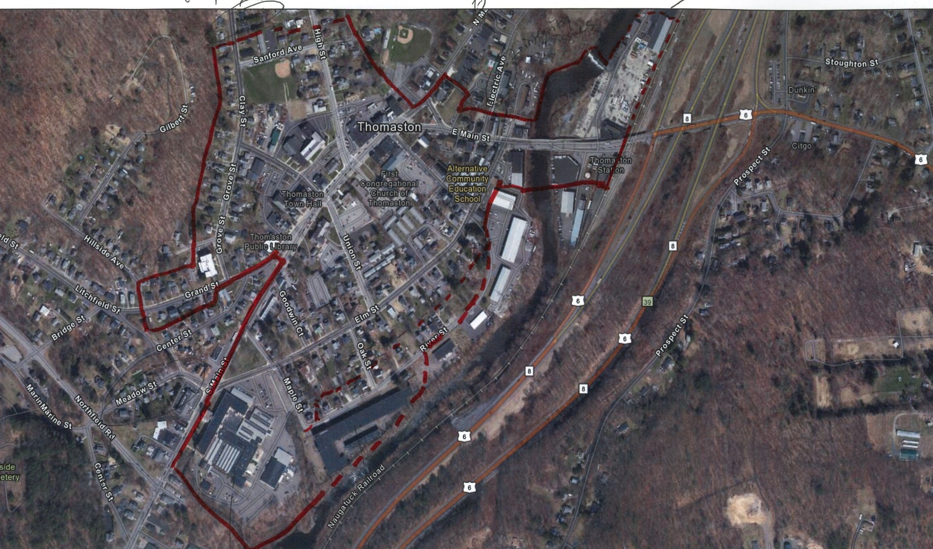
The Town of Thomaston and Connecticut State Historic Preservation Office (SHPO), invite residents to learn about a proposed National Register of Historic Places nomination for the downtown. National Register listing is an honorary status, which celebrates places with important local history. Downtown Thomaston has a wealth of historic resources, worthy of recognition. The historic community spaces, businesses, mill housing, and mill complexes all contribute to the Town’s identity and unique character.

Jenny Scofield, National Register Coordinator for SHPO, and Renee Tribert of Preservation Connecticut will provide an overview of the National Register program and benefits of designation.

Please join us to learn more about this effort!

