How to Complete the 2026 Online Personal Property Declaration
  - Taxpayer Tutorial
State of Connecticut Long Form Only — 2026
Use this guide to register, activate your account, complete the sections that apply to your business, and submit your online personal property declaration.
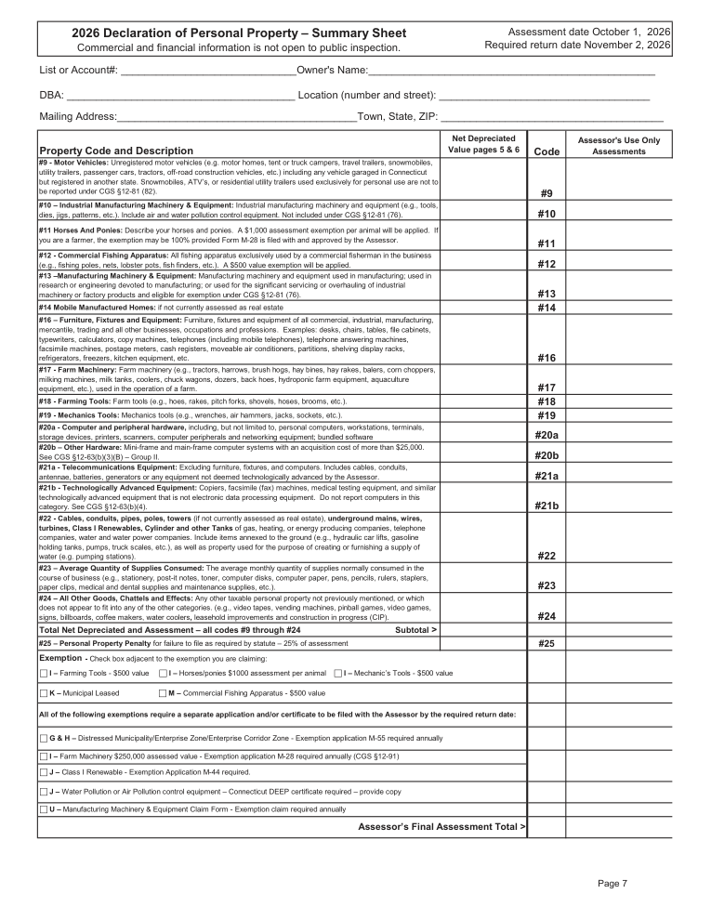

1. Login or New User Registration
Use the link provided in your Personal Property Declaration mailing to open the online system.
FIRST-TIME USERS: Click NEW USER REGISTRATION. You must register before beginning your declaration.
RETURNING USERS: Enter your existing Username and Password, then click SIGN IN. Use FORGOT PASSWORD OR USER NAME? if needed.
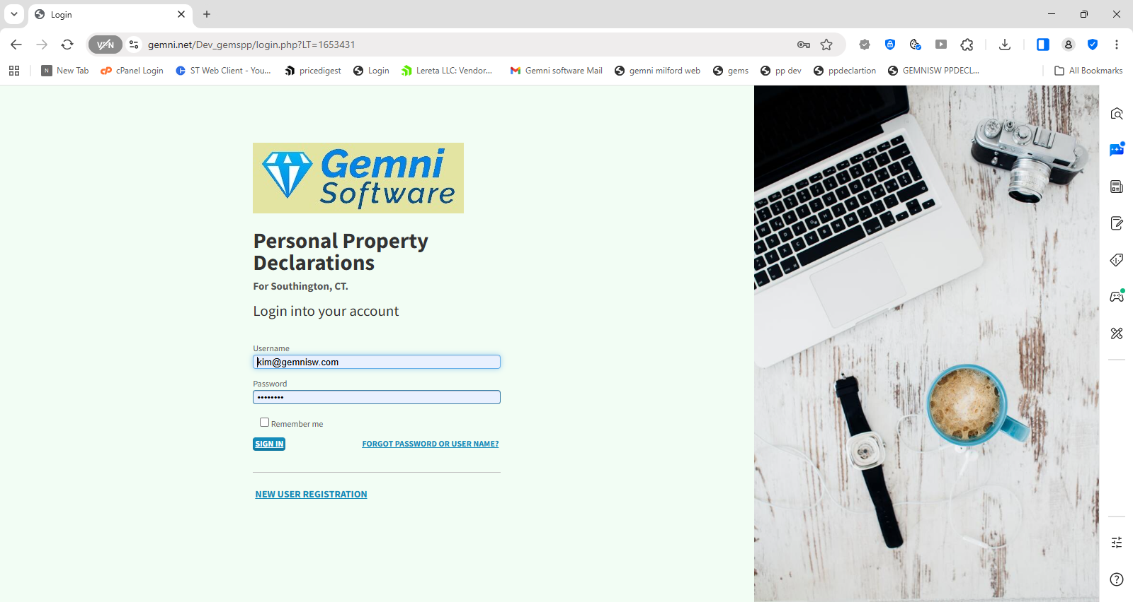

2. New User Registration
Create a User ID and Password, confirm the Password, and enter your Email address.
PIN: Enter the PIN provided in your Personal Property Declaration mailing from the Assessor’s Office.
When all required information has been entered, click REGISTER. Keep your User ID and Password for future access.
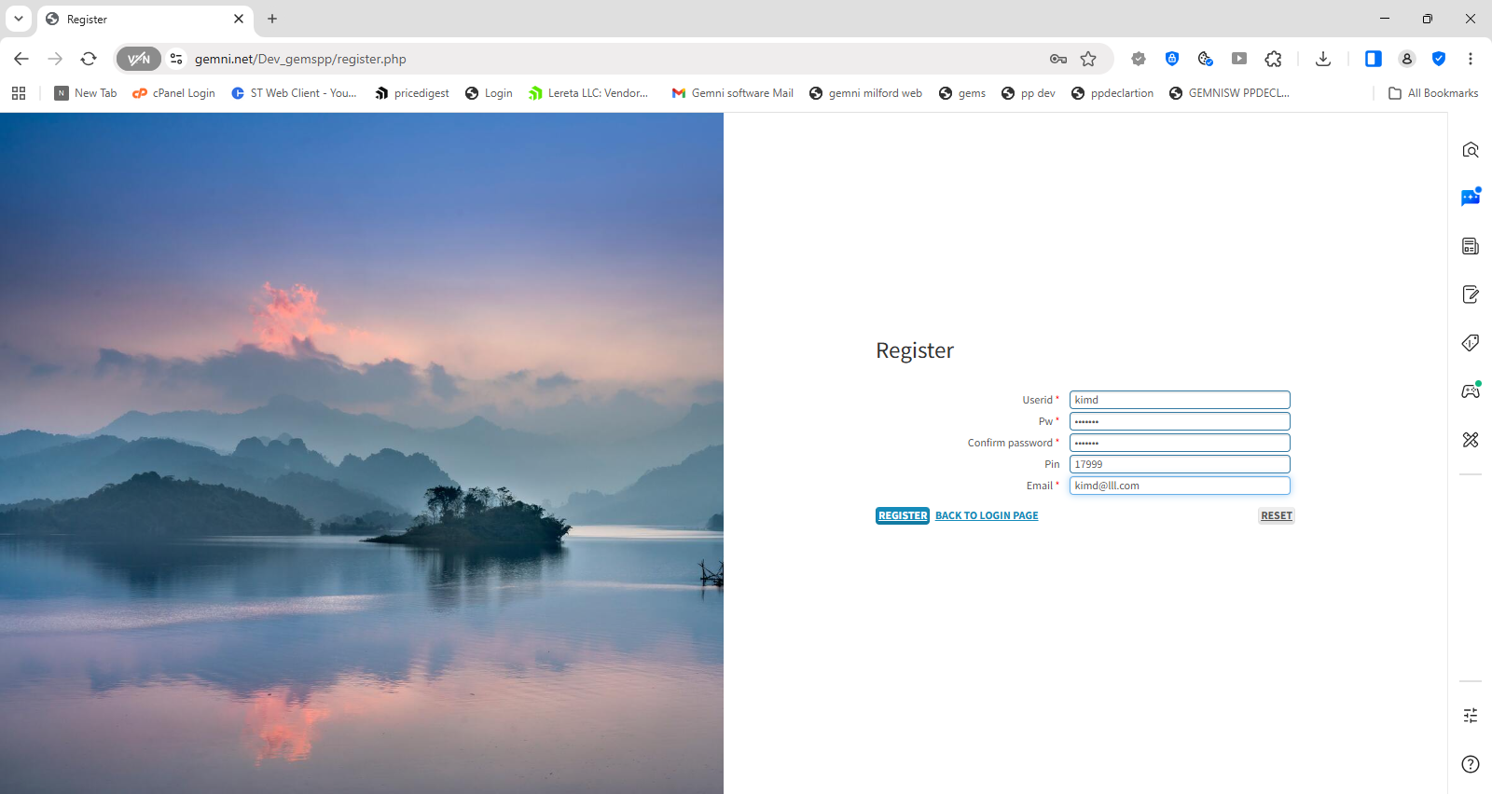

After Registration Account Activation
After you click REGISTER, the “Registration successful!” message appears.
1. Check the email address you entered during registration.
2. Follow the instructions in the email to activate your account.
3. If you do not see the email, check your spam or junk folder.
You will receive an email with instructions on activating your account.
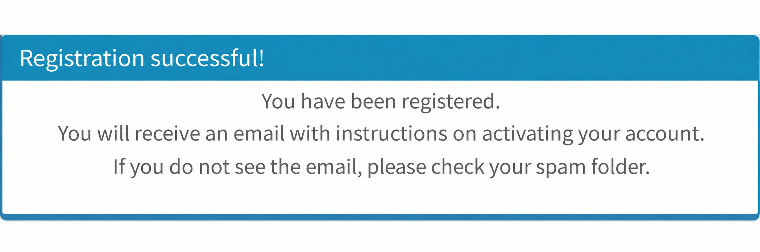

After Registration Confirmation Email
Check your email after registering
Open the email titled “Notification on registering.” If you do not see it, check your spam or junk folder.
Click the confirmation link in your email to confirm your account and continue to your declaration.
If the link does not open, copy and paste the full link from your email into your browser.
Example shown for Milford. Use the link in your own email.
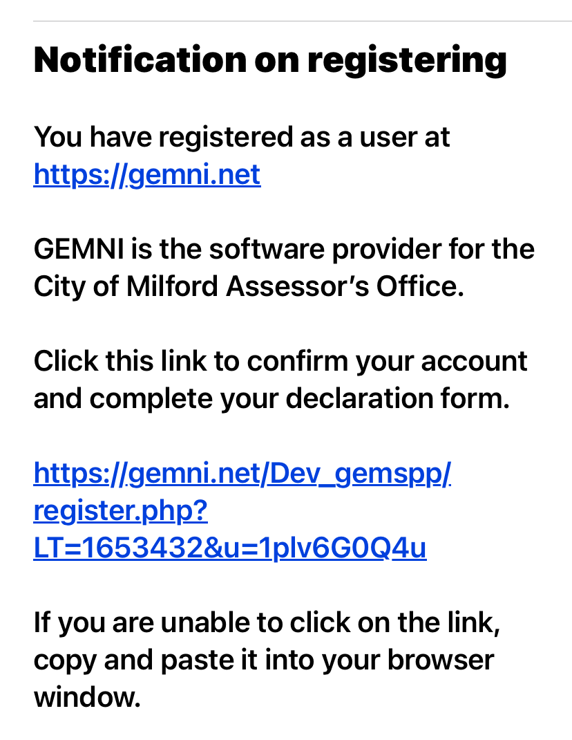

After Account Activation Main Menu
After completing the email activation step, you reach the main menu.
Click “File Declaration” to begin your personal property declaration.
Choose the top option shown on this screen.
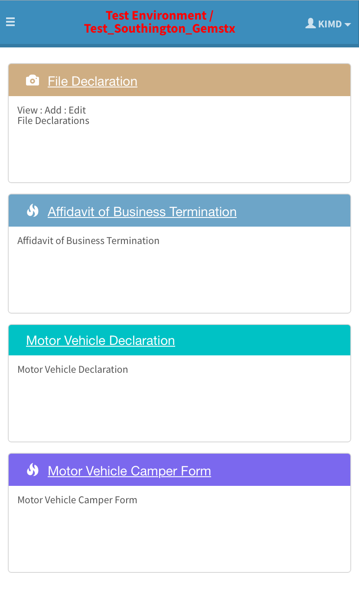

3. Start on the File Declaration Page
Begin by reviewing the File Declaration page and the Business Data section.
IMPORTANT: Click the red “Critical — To submit form properly” message and read the instructions before you begin.
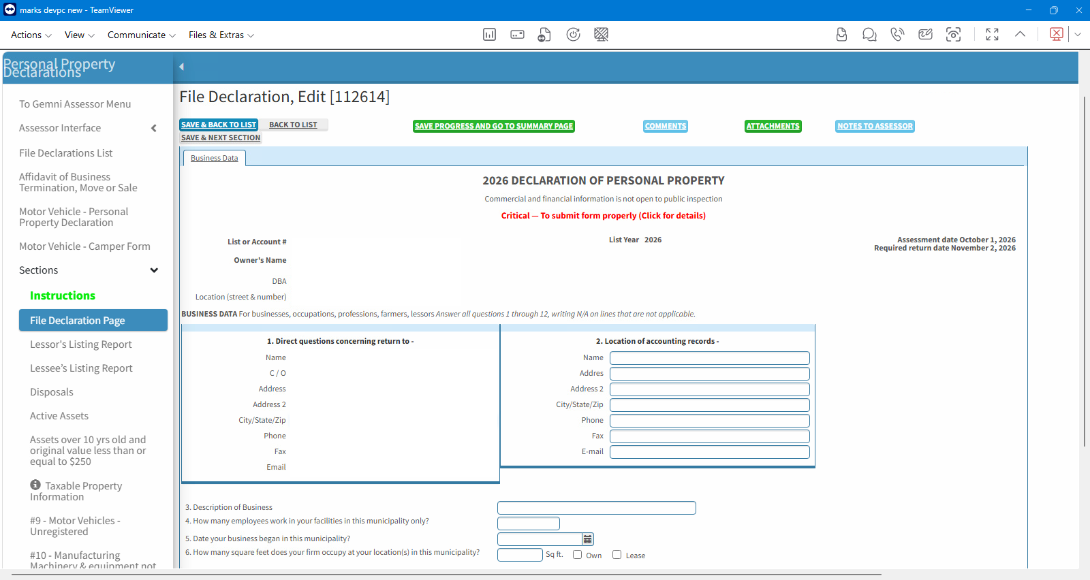

4. Complete Business Data
Complete the Business Data questions that apply to your business. Follow the instructions on the form, including entering N/A where required.
Tip: Scroll the LEFT Sections panel to locate the property code or schedule you need.

How to Move Through the Online Declaration
You do not have to complete every property code. Complete the sections that apply to your business.
SAVE & NEXT SECTION
Saves the page you are on and moves you to the next section.
LEFT SECTIONS PANEL
You may also use the menu on the left to go directly to Lessor, Lessee, Disposals, Active Assets, or a specific property code such as #16.
PREVIOUS / NEXT SECTION
Within the declaration, use these buttons to move backward or forward through sections when available.
SAVE PROGRESS AND GO TO SUMMARY PAGE
When you have completed the sections that apply, save your work and go to the Summary Page.
SUMMARY → SIGNATURE → SAVE AND SUBMIT
Review your declaration, complete the signature step, and then click SAVE AND SUBMIT. Your declaration is not filed until the final submission is completed.
TIP: Save as you go. You can return to a section before final submission if you need to review or make a change.

5. Example Reporting Furniture, Fixtures and Equipment
If your business needs to report furniture, fixtures or equipment, scroll through the Sections menu and select Code #16.
In the Sections menu on the left, select Code #16. Open the schedule and enter the applicable costs.
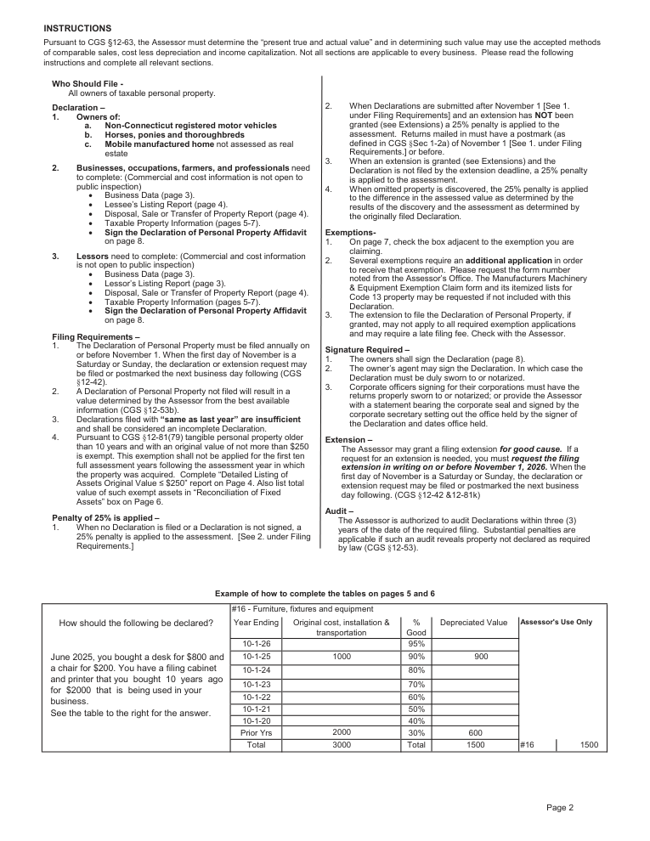

Long Form Filing and Business Status
Cover page: filing requirement and business termination, move or sale
- Use this section if the business/property was sold, moved, or terminated.
- The form states the declaration must be signed and returned by November 2, 2026 to avoid the late-filing penalty.
- Online tutorial note: taxpayers still operating the business continue through the declaration sections.
Official 2026 Connecticut Long Form — page 1
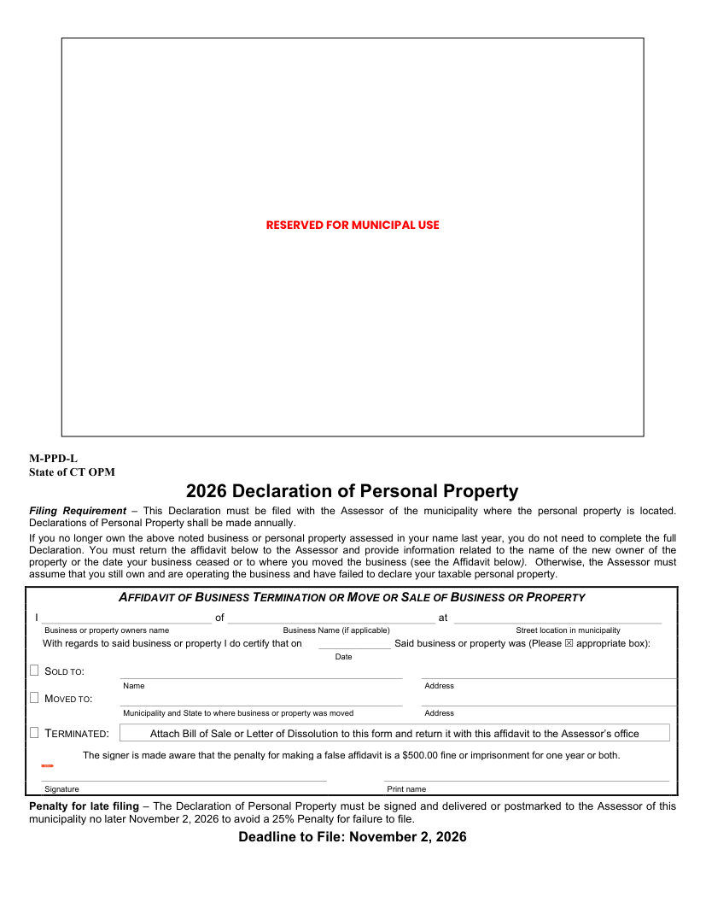

Long Form Instructions
Who should file, filing rules, exemptions, signature requirements and extension information
- Not every schedule applies to every taxpayer; complete all relevant sections.
- Businesses generally complete Business Data, Lessee information, disposals, taxable-property schedules, and the affidavit.
- Lessors also complete the Lessor’s Listing Report.
- The instructions explain the 25% penalty, exemption applications, extension requests, and audit provisions.
Official 2026 Connecticut Long Form — page 2
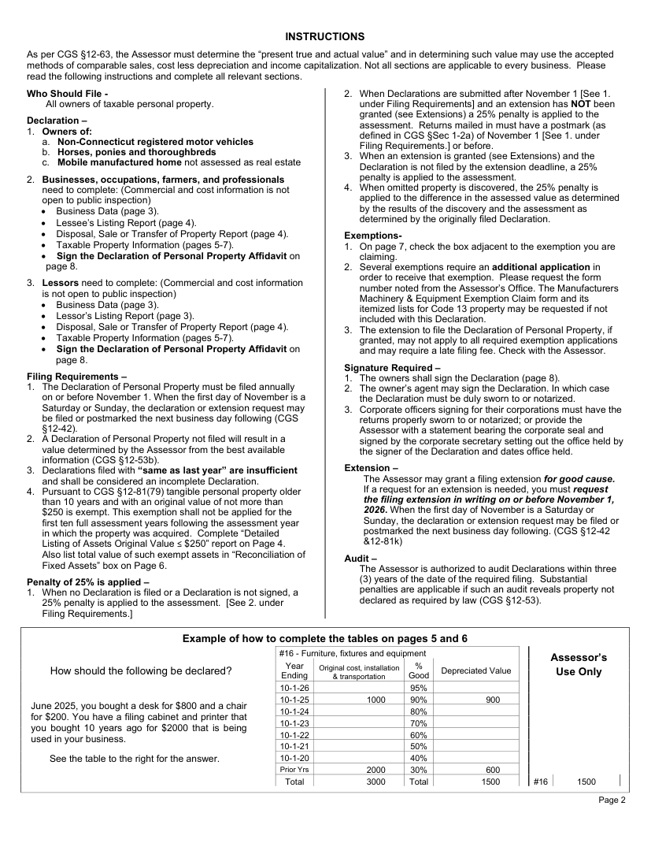

Long Form Business Data
Questions 1–12
- Complete contact/accounting-record information and describe the business.
- Enter employees, start date, square footage, ownership type and business type.
- Answer the questions about property in other municipalities, other businesses at the location, leased property, and borrowed/consigned/stored/rented property.
- Enter N/A where the form requires it and the question does not apply.
Official 2026 Connecticut Long Form — page 3
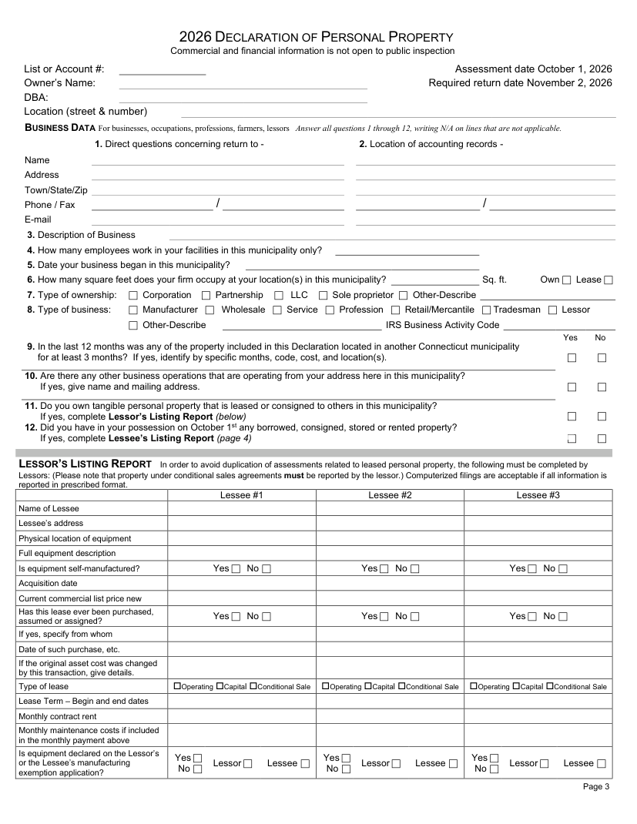

Long Form Lessor’s Listing Report
For property you own and lease to others
- Complete this section when the business owns tangible personal property leased or consigned to others.
- Report lessee, equipment description/location, acquisition information, lease type and lease term.
- Include the requested information concerning manufacturing exemption reporting when applicable.
Official 2026 Connecticut Long Form — page 3

Long Form Lessee’s Listing Report
For leased, borrowed, consigned, loaned, rented or stored property in your possession
- Identify the lessor and the equipment in your possession as of the assessment date.
- Report lease number, description/model, serial number, year, lease term, rent and acquisition cost.
- Answer the questions about disposed leased items, acquired leased items, and whether costs are reported elsewhere.
Official 2026 Connecticut Long Form — page 4
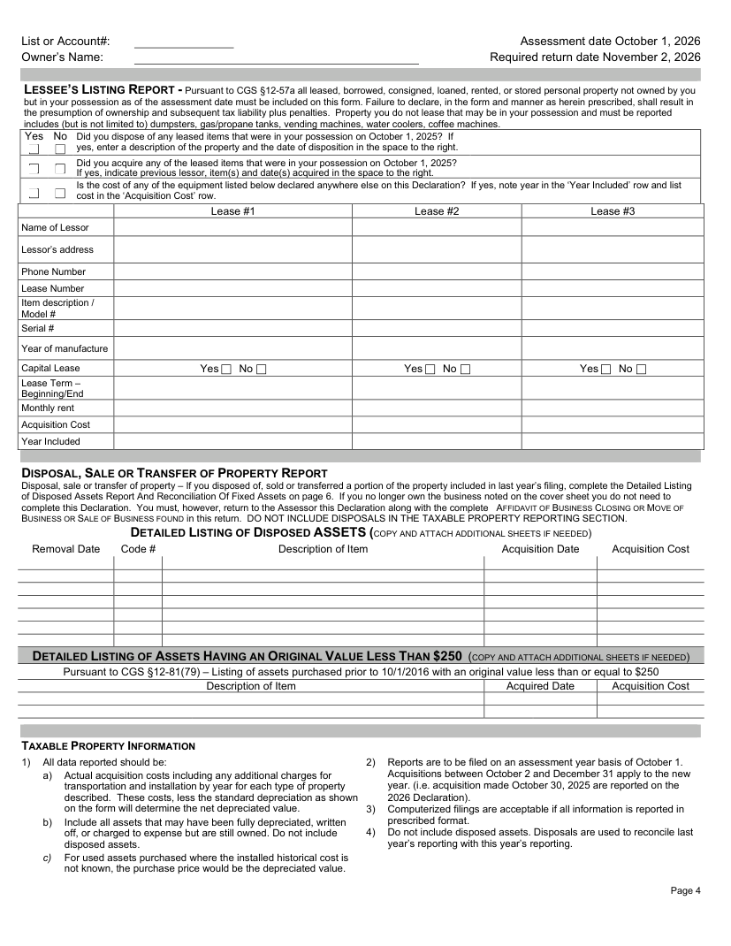

Long Form Disposals and Low-Cost Older Assets
Disposed assets and assets with original value of $250 or less
- Do not include disposed assets in the taxable-property schedules.
- List assets disposed of, sold or transferred from last year’s filing with removal date, code, description, acquisition date and cost.
- Separately list qualifying older assets with an original value of $250 or less as directed by the form.
Official 2026 Connecticut Long Form — page 4

Long Form Taxable Property Codes #9–#16
Complete only the schedules that apply
- #9 Unregistered motor vehicles / certain vehicles garaged in Connecticut.
- #10 Manufacturing machinery & equipment not eligible for the stated exemption.
- #11 Horses and ponies; #12 Commercial fishing apparatus.
- #13 Manufacturing machinery & equipment eligible for exemption; #14 Mobile manufactured homes.
- #16 Furniture, fixtures and equipment.
Official 2026 Connecticut Long Form — page 5
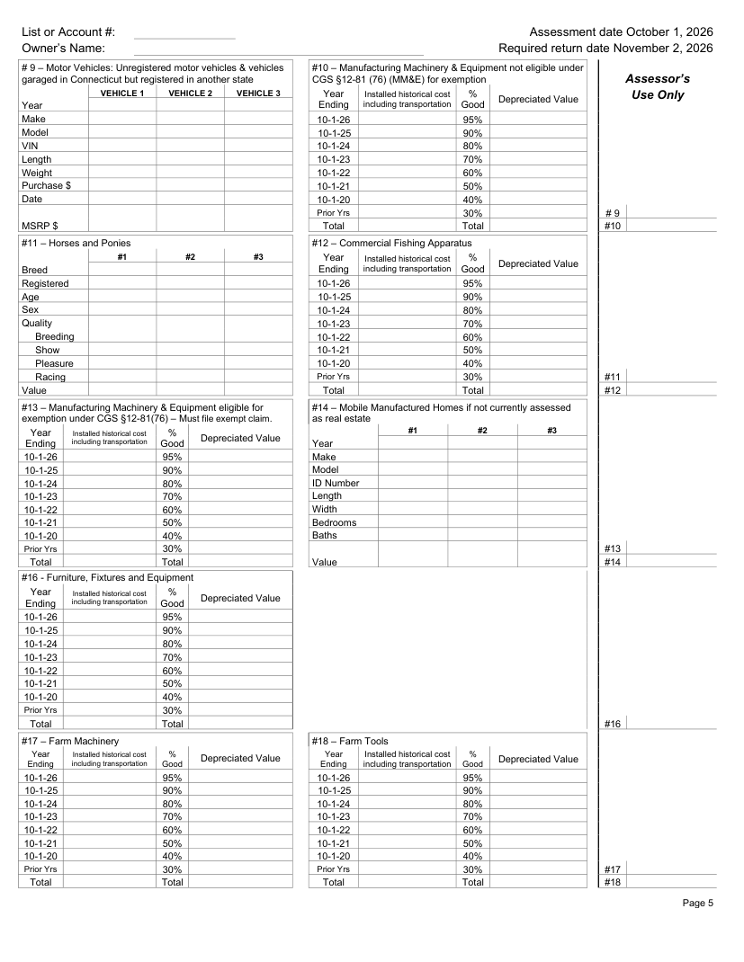

Long Form Taxable Property Codes #17–#18
Farm machinery and farm tools
- #17 Farm Machinery: report installed historical cost by year and the resulting depreciated value.
- #18 Farm Tools: report the applicable costs by year.
- Use the year-ending rows and depreciation percentages shown on the form.
Official 2026 Connecticut Long Form — page 5

Long Form Taxable Property Codes #19–#24
Mechanics tools, computer/EDP, telecommunications and other property
- #19 Mechanics Tools.
- #20 Electronic Data Processing / computer equipment (the online/summary presentation may separate computer categories).
- #21 Telecommunications Equipment, including the applicable categories.
- #22 Cables, conduits, pipes, poles, towers and related property.
- #23 Average Quantity of Supplies Consumed; #24 All Other Goods, Chattels and Effects.
Official 2026 Connecticut Long Form — page 6
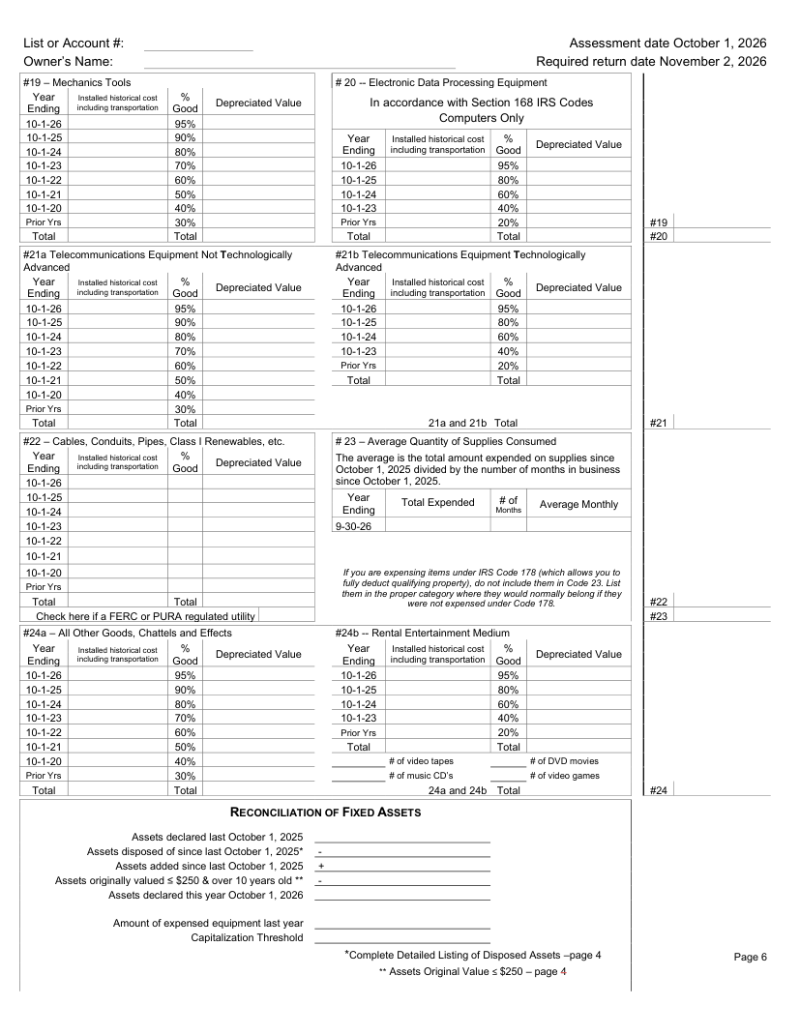

Long Form Reconciliation of Fixed Assets
Reconcile last year’s assets to the current declaration
- Use the reconciliation section to account for additions, disposals and the current-year asset totals.
- Disposed assets should agree with the Detailed Listing of Disposed Assets.
- Include the qualifying low-cost older assets where the form directs.
Official 2026 Connecticut Long Form — page 6

Long Form Summary, Penalty and Exemptions
Review all property codes before signing
- Review the net depreciated values for all applicable property codes.
- The form includes the personal-property penalty line and exemption check boxes.
- Some exemptions require a separate application and/or certificate filed with the Assessor.
Official 2026 Connecticut Long Form — page 7
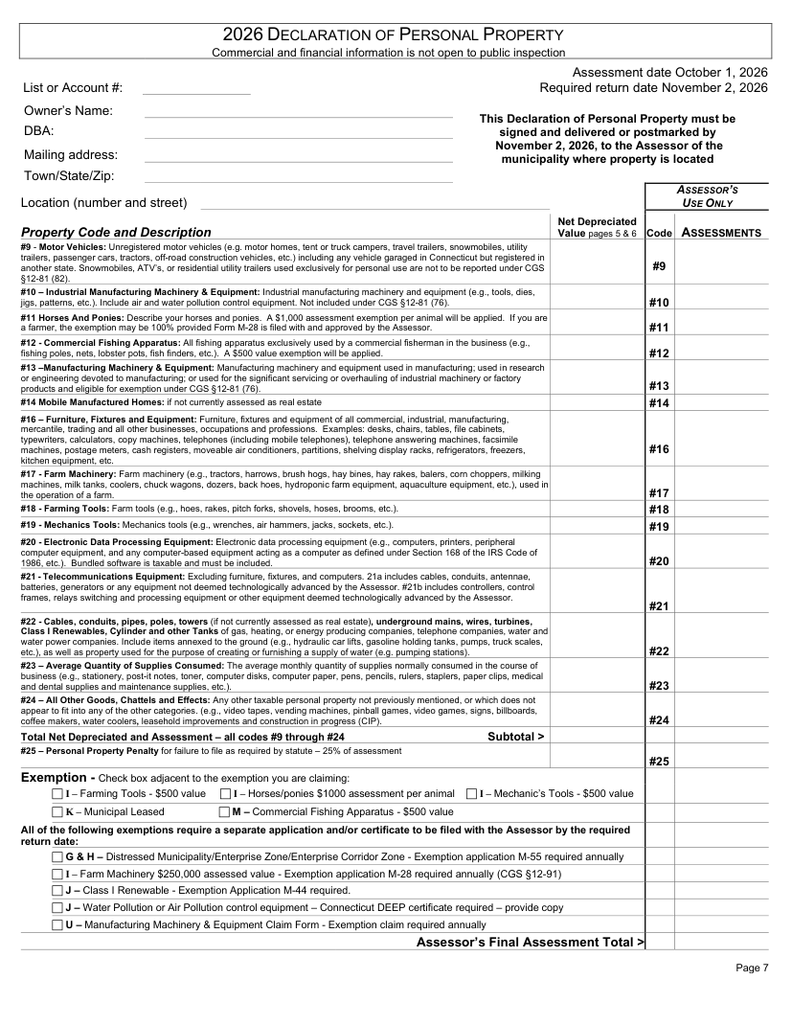

Long Form Declaration Affidavit
The declaration must be properly signed before filing
- Complete the Owner section or Agent section, as applicable.
- Agent signatures must be witnessed as shown on the official form.
- The online process should not be considered complete until the signature step is finished and SAVE AND SUBMIT is selected.
Official 2026 Connecticut Long Form — page 8
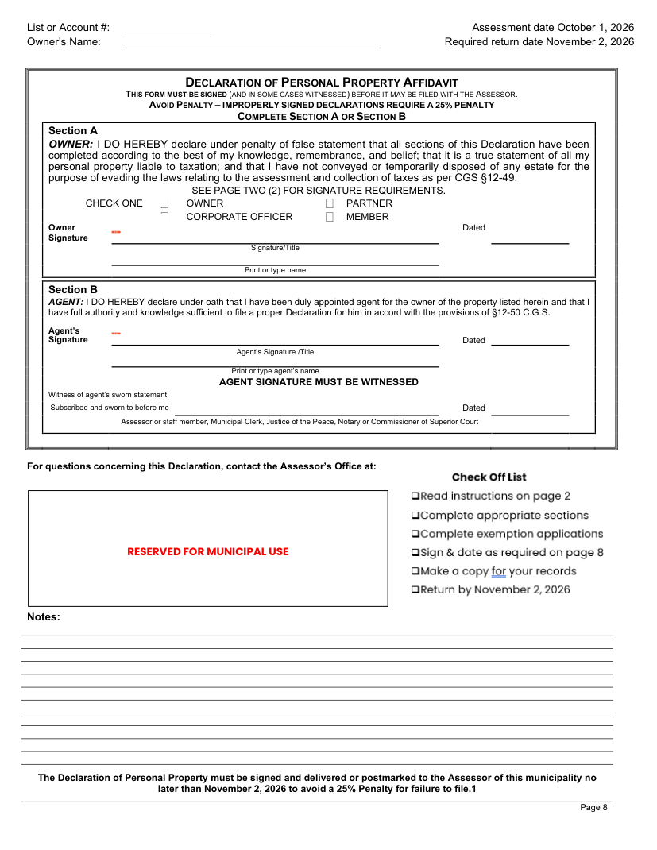

6. Save Your Work as You Go
SAVE & NEXT SECTION
Saves the information entered on the current section and continues to the next section.
SAVE PROGRESS AND GO TO SUMMARY PAGE
Use this when you are finished entering the sections that apply and are ready to review the declaration.

7. Review the Summary Before Signing
Review the declaration summary carefully before proceeding to the signature step.

8. Complete the Signature Step
Choose Save and Go to Signature. Read the red message that appears, then select Continue.
The declaration must be signed before it can be filed.

9. FINAL STEP Save and Submit
After signing, you MUST click SAVE AND SUBMIT.
Saving your work or completing the signature step alone does not submit the declaration.
FINAL CHECK: Review the Summary Page → complete the Signature step → click SAVE AND SUBMIT. Saving progress or signing alone does not file the declaration.

Updated Online Filing Workflow
2026 Personal Property Declaration
After Login — Declaration Forms
After entering your Username and Password and signing in, the Declaration Forms screen will appear. Locate the declaration you wish to complete and click Edit Form.
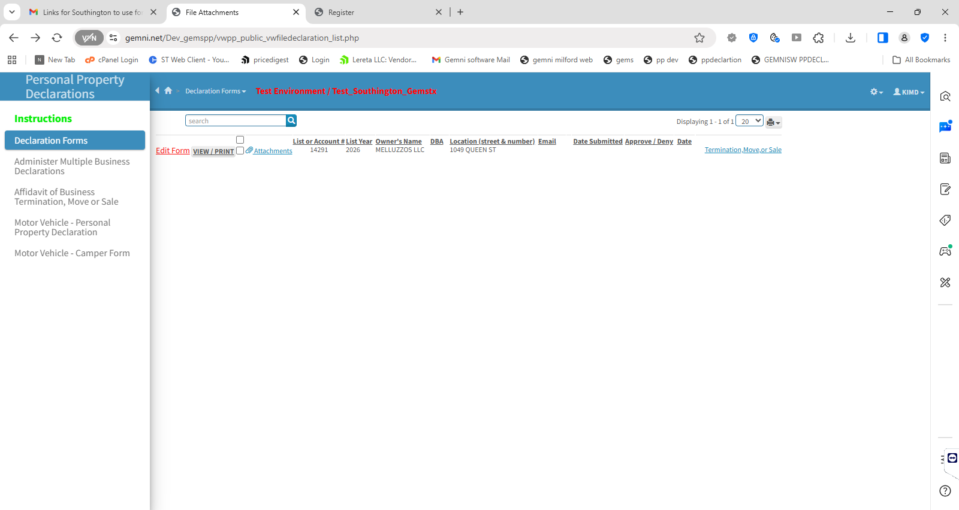

Complete Your 2026 Declaration
After clicking Edit Form, your 2026 Declaration of Personal Property will open. Review and complete the Business Data and each section that applies to your business. Use SAVE & NEXT SECTION to move through the form, or select a specific section from the Sections menu on the left. When all applicable sections are complete, proceed to the Summary Page to review and submit your declaration.
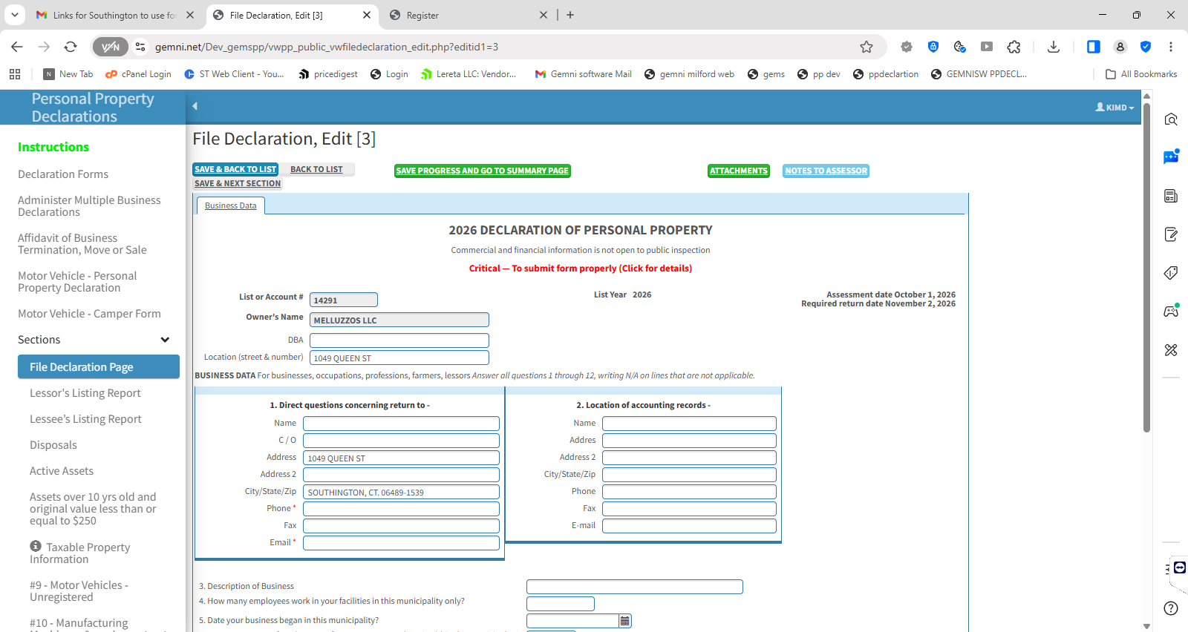

Submit Your Declaration
After reviewing your declaration and completing the required signature information, click Submit. A confirmation message will appear advising that once the declaration is submitted, it can no longer be edited. Click SUBMIT to finalize the declaration, or CANCEL to return and make changes.
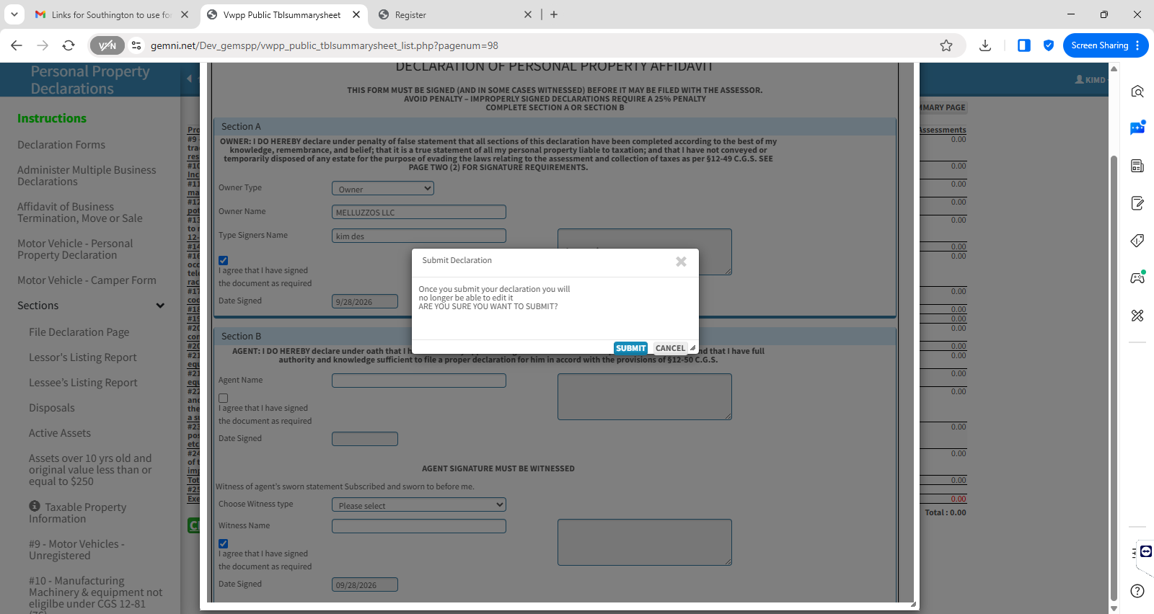

Declaration Successfully Submitted
Once your declaration has been submitted, you will return to the Declaration Forms screen. The Date Submitted will be displayed and the declaration will show VIEW / PRINT only. Click VIEW / PRINT to review or print your completed declaration. Once submitted, the declaration can no longer be edited.
