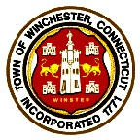
TOWN OF WINCHESTER – CITY OF WINSTED
Town Hall – 338 Main Street
WINSTED, CONNECTICUT 06098

WINCHESTER RECREATION DEPARTMENT
Wed 8/5/26: 7:00pm
P. Francis Hicks Room Town Hall

- Call to order
- Agenda Review
- Approval of 6/3/26 Regular Meeting Minutes
- Public Comment
- Chairman Report
- WYL BB/SB Update : Mike Bednarz WYL President
- School usage Issues
- Ryan Field Adult SB Program : Post game environment
- Youth Basketball: Brandon Fields action
- Directors Report/Programs
- Old Business
- New Business
- Adjournment

